CDFW Methods for Defining the Sample Frame and Estimating Habitat Volumes for Juvenile Pelagic Fish Studies in the San Francisco Estuary

Monitoring Survey Design Team

Technical Note #1

**VERSION 2 DRAFT FOR STEERING COMMITTEE REVIEW**

Prepared by

Celeste Dodge, Steven B. Slater, and Aroon R. Melwani

California Department of Fish and Wildlife and Applied Marine Sciences, Inc

December 19, 2025

Introduction 3

Spatial Extent and Sample Frame Definition 3

Depth and Bathymetry 6

Volume Estimation 9

Assumptions 14

Acknowledgements 15

References 15

Appendix A. Volume estimation analysis maps by subregion 17

Appendix B. Waterbody delineation methods 33

Introduction 33

Summary 33

Steps in ArcGIS Pro 33

Appendix C. Volume estimation procedure 37

Introduction 37

Volume Estimation R Script 37

Appendix D. Full sample frame statistics for subregions in one-meter depth slices 48

Appendix E. Summary sample frame statistics at scales of region and stratum 55

# Introduction

This technical note describes the methods applied by the Monitoring Survey Design Team (Design Team) to define the sample frame used as the basis for the design and analysis of the California Department of Fish and Wildlife (CDFW) long-term monitoring studies conducted in the San Francisco Estuary (SFE). These studies include the Smelt Larval Survey, 20-mm Survey, Summer Townet Survey, Fall Midwater Trawl (FMWT), and the San Francisco Bay Study (SFBS). Here, we introduce the methods intended to standardize approaches to spatial extents, water surface elevation, and depths used to determine surface area and water volumes for catch per unit of effort expansion factors.

The goals of this document are to describe the sample frame and methods for calculating expansion factors, and to provide the resulting surface area and volumes data at region, stratum, and subregion spatial scales in the SFE. This effort is intended to provide a spatial design to standardize methods for estimating regional fish abundance across CDFW monitoring studies collectively known as the Interagency Monitoring Program (IEP) fish surveys.

The current version of this technical note, version 2, provides new water volume calculation methods that incorporate steps used by the US Fish and Wildlife Service (USFWS; Mitchell et al. 2018) and application of new bathymetric data sources. The principal updates since version 1 are the inclusion of the SFBS in the sample frame approach, adjustments to subregion boundaries, improved naming conventions, and updates to underlying data sources and methods used to estimate the pelagic habitat volumes for the SFE, including the creation of an improved layer to define the waterbody. In version 2, volumes were estimated for two water surface elevations and for greater depth classifications. The bathymetry utilized in version 1 was produced in 2016, while the 2025 procedure used the 2025 digital elevation model (DEM) and eliminated unnecessary DEM transformation to avoid data loss and unreliability. Lastly, version 2 includes a procedure for delineating the SFE and provides a new spatial data resource called the Design Team waterbody (here forward, waterbody).

# Spatial Extent and Sample Frame Definition

The spatial extent of these CDFW studies and this design are based on the continuous water accessible to CDFW fish sampling, extending from South San Francisco Bay, upstream through the legal Delta. We define the sample frame as the continuous geographic area containing the SFE, subdivided into smaller nested areas we term regions (n=6), strata (n=12), and subregions (n=35). Our operational and analysis footprints are defined as the accessible water within the sample frame. At the largest spatial scale, six regions divide embayments, rivers, and the Delta (Figure 1a and 1b). The six regions are divided into 12 strata, and at the finest spatial scale, the sample frame is divided into 35 subregions (Appendix A). Note that there is overlap between these categorizations, with six strata being spatially distinct, and six strata replicating region and subregion polygons. The Confluence Region is not subdivided at the stratum level. Strata that are not subdivided at the subregion level are: the South San Francisco Bay, Central San Francisco Bay, Suisun Marsh, Cache Slough and Liberty Island, and North and South Forks Mokelumne River strata (Table 1).

The original set of region, stratum, and subregion polygons were developed by the USFWS for the Delta Smelt Life Cycle Model (Mitchell et al. 2018) and later updated for the USFWS Enhanced Delta Smelt Monitoring (EDSM) program. In 2022, USFWS provided EDSM strata and subregions extending from the Delta west through Mid-San Pablo Bay (Polansky and Studen 2019). We refined and supplemented polygons at all three spatial scales, including defining new polygons for areas relevant to the CDFW surveys beyond the EDSM extent, notably for Montezuma Slough, San Pablo Bay, and San Francisco Bay (SF Bay).

Version 2 of the Design Team sample frame relies on geodatabase topology to prevent gaps and overlaps among polygons, creating a set of contiguous, analysis-ready, nested polygon layers. In version 2, geographic names were adjusted to follow naming conventions, spatial logic, and historical nomenclature, particularly for regions and strata. These updated polygon layers Design_Subregions, Design_Strata, and Design_Regions are currently available in the SpatialDesign geodatabase at the Six Agency Monitoring Redesign file share as well as on the *pelagicsurveys* GitHub repository maintained by David Bosworth (California Department of Water Resources, DWR). [A public resource location for these data is TBD].

Subregion boundaries often lie between embayments or drainages (e.g. Honker Bay, Mokelumne River), but some hydrological features were divided into smaller units based on resource management interests (e.g. Lower and Upper Napa River) or geographic scope of monitoring efforts (e.g. many surveys sample in East San Pablo Bay, but not further downstream into Middle or West San Pablo Bay). To ensure that transects of SFBS and FMWT tows for any one station are contained within a single subregion, subregion boundaries were modified in three places since version 1. Some sample frame boundaries are collocated with bridges, for convenience and to exclude areas that are inaccessible to sampling, such as beneath the Benicia-Martinez Bridge. The names and nesting of subregions, strata, and regions are available in Table 1. In calculating the surface areas (km2) and water volumes (km3) for each subregion, the analysis footprint was the intersection of the sample frame with the waterbody.

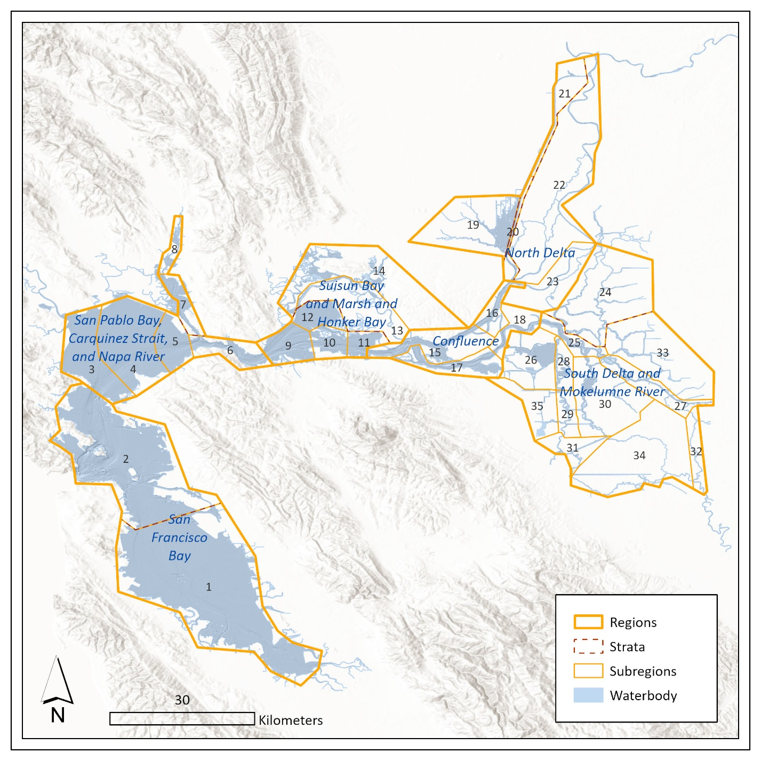

**Figure 1a**. Map of the sample frame and Design Team Waterbody with geographic sorting of subregions from downstream to upstream identified by number, regions names, and sample frame polygons including subregion, strata, and region scales.

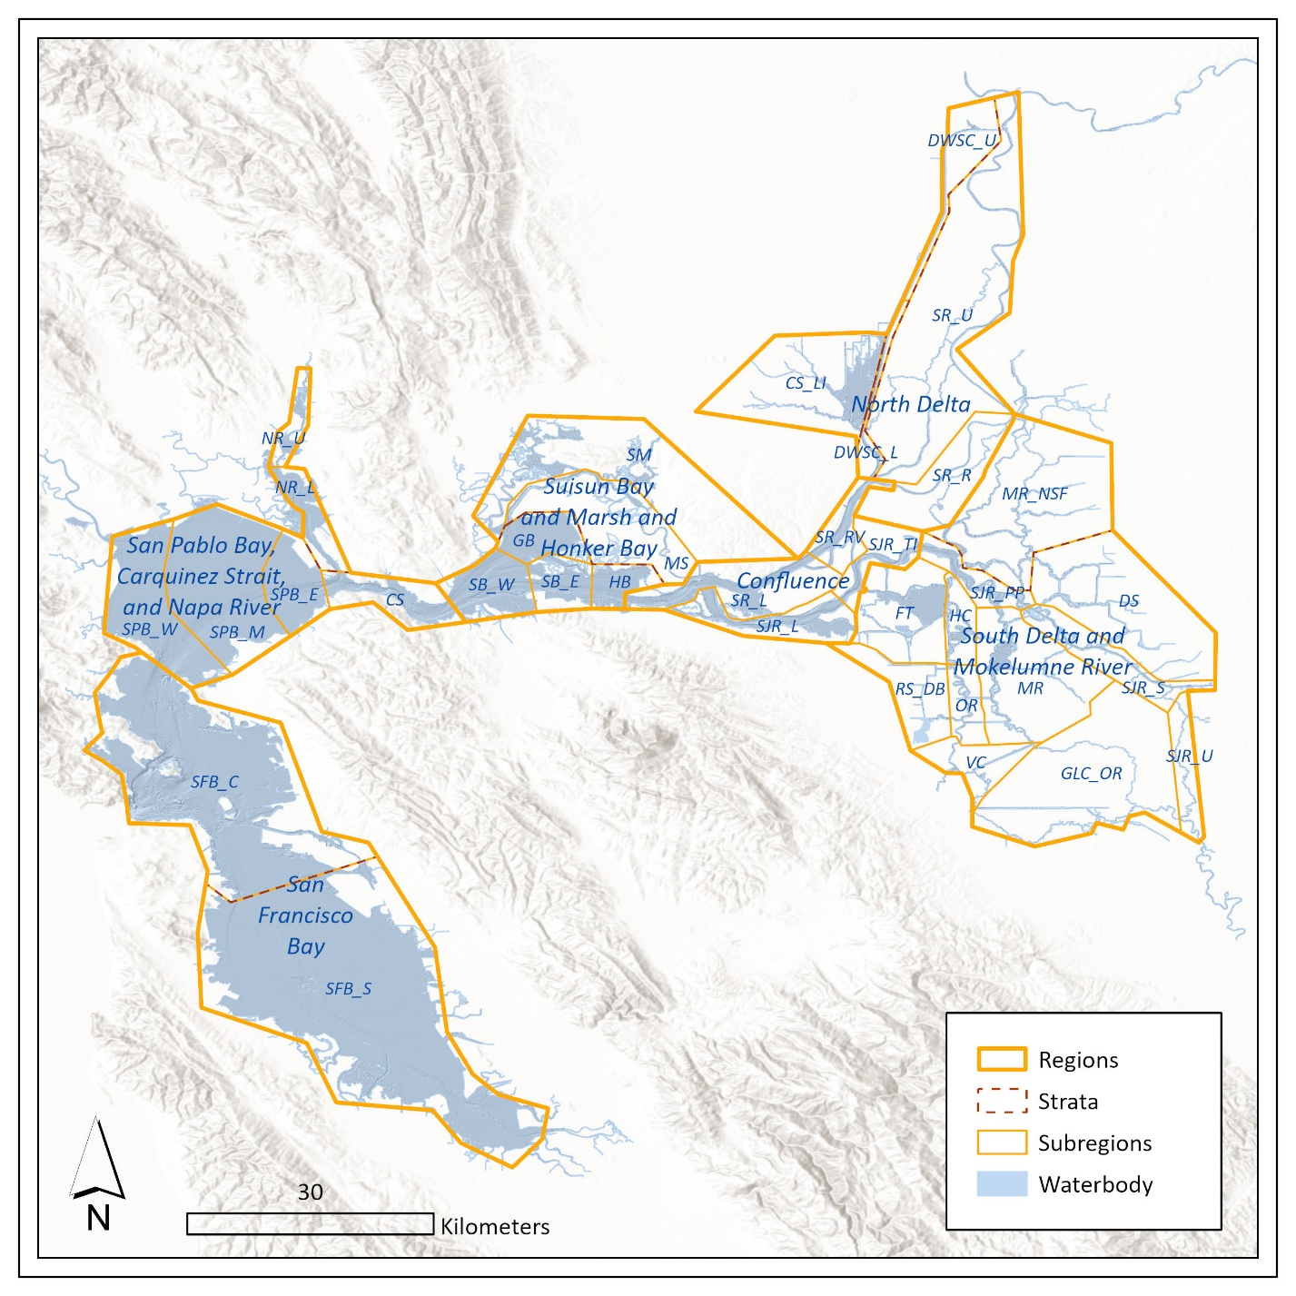

**Figure 1b**. Map of the sample frame and Design Team Waterbody with subregion alpha codes, regions names, and sample frame polygons including subregion, strata, and region scales.

# Depth and Bathymetry

Bathymetric data were obtained from Version 4.3 of the San Francisco Bay and Sacramento-San Joaquin Delta DEM for Modeling, (DWR and U.S. Geological Survey, 2025). In our analysis, all elevations were referenced to the North American Vertical Datum of 1988 (NAVD 88). The 10 m2 resolution of the DEM provided the elevation values used to calculate depth and derive the area and volume estimations. Mean Tide Level (MTL) was used to represent the water surface elevation and was assumed to be 1.25 m in the EDSM-consistent regions. To the west of this area, MTL was lowered to 1 m in Carquinez Strait, San Pablo Bay, and SF Bay (see Tables 1 and 2; and Appendices A, D, and E).

Depth classifications are important for ensuring both the safety and feasibility of sampling operations in a tidal system. The Design Team defines accessible water as depths of at least 1.22 m (4 ft) deep at MTL. In practice, CDFW studies do not sample in water less than 1.83 m (6 ft), due to vessel draft limitations and net specifications to reduce the risk of entanglement. The volume assessment described here applies a 4-ft depth cutoff and is based on MTL elevations in NAVD 88.

The original CDFW area and volume weighting factors (circa 1950s-1960s) were based on MTL conditions and were estimated to have a reliability of ±15 percent (Chadwick 1964). In subsequent decades, nautical charts were used to derive expansion factors, referenced to mean lower low water (MLLW) with differing minimum depths for accessible water (sometimes 3 ft). Historically, access to sampling areas was determined directly from NOAA nautical charts. The relevant historical NOAA nautical charts at the 1:40,000 scale include:

* 18649 – Entrance to San Francisco Bay
* 18651 – South SF Bay
* 18654 – San Pablo Bay
* 18656 – Suisun Bay
* 18661 – Sacramento and San Joaquin Rivers
* 18662 – Sacramento River

Assessment of access to new sampling sites or to assess historical stations that may no longer be accessible (e.g. due to aquatic vegetation), relies on depth information. CDFW and the Design Team have applied the following depth accessibility rankings: > 6 ft = accessible; 4-6 ft = questionable, and < 4 ft = too shallow. Site accessibility is a function of both vessel draft requirements and the depth needed to deploy sampling gear effectively. For example, although CDFW and the Design Team use 4 ft as the minimum depth for accessibility, EDSM differentiates deep and shallow areas at 5.7 ft for Delta Smelt sampling gear and requires at least an 8 ft depth to deploy its Kodiak trawl. Inaccessible water (e.g. behind levees, or less than 4 ft deep) was excluded from our operational and analysis footprints.

Historically, catch expansion factors were calculated separately for each survey and often on a station-by-station basis. The new methodology standardizes expansion volumes across surveys by applying consistent geographic units across the sample frame. For individual survey history and details on how expansion factors for pelagic fish abundance were previously derived by each survey, please refer to project metadata. Additional details on abundance index calculations, volume expansion factors, and depth classification are available at: <https://wildlife.ca.gov/Conservation/Delta>.

**Table 1.** Summary of regions, strata, and subregions assigned by number within the San Francisco Estuary.

|  |  |  |  |  |  |
| --- | --- | --- | --- | --- | --- |
| Region | Stratum | Subregion | MTL (m) | Subregion Order | Subregion Code |
| San Francisco Bay | South SF Bay | South SF Bay | 1 | 1 | SFB_S |
| Central SF Bay | Central SF Bay | 1 | 2 | SFB_C |
| San Pablo Bay, Carquinez Strait, and Napa River | San Pablo Bay and Carquinez Strait | West San Pablo Bay | 1 | 3 | SPB_W |
| Mid San Pablo Bay | 1 | 4 | SPB_M |
| East San Pablo Bay | 1 | 5 | SPB_E |
| Carquinez Strait | 1 | 6 | CS |
| Napa River | Lower Napa River | 1.25 | 7 | NR_L |
| Upper Napa River | 1.25 | 8 | NR_U |
| Suisun Bay and Marsh and Honker Bay | Suisun and Honker Bays | West Suisun Bay | 1.25 | 9 | SB_W |
| East Suisun Bay | 1.25 | 10 | SB_E |
| Honker Bay | 1.25 | 11 | HB |
| Grizzly Bay | 1.25 | 12 | GB |
| Suisun Marsh and Montezuma Slough | Montezuma Slough | 1.25 | 13 | MS |
| Suisun Marsh | 1.25 | 14 | SM |
| Confluence | Confluence | Lower Sacramento River | 1.25 | 15 | SR_L |
| Sacramento River near Rio Vista | 1.25 | 16 | SR_RV |
| Lower San Joaquin River | 1.25 | 17 | SJR_L |
| San Joaquin River at Twitchell Island | 1.25 | 18 | SJR_TI |
| North Delta | Cache Slough and Liberty Island | Cache Slough and Liberty Island | 1.25 | 19 | CS_LI |
| Sacramento River Deep Water Ship Channel | Lower Sacramento River Deep Water Ship Channel | 1.25 | 20 | DWSC_L |
| Upper Sacramento River Deep Water Ship Channel | 1.25 | 21 | DWSC_U |
| Sacramento River Mainstem | Upper Sacramento River | 1.25 | 22 | SR_U |
| Sacramento River near Ryde | 1.25 | 23 | SR_R |
| South Delta and Mokelumne River | North and South Forks Mokelumne River | North and South Forks Mokelumne River | 1.25 | 24 | MR_NSF |
| South Delta | San Joaquin River at Prisoners Pt | 1.25 | 25 | SJR_PP |
| Franks Tract | 1.25 | 26 | FT |
| San Joaquin River near Stockton | 1.25 | 27 | SJR_S |
| Holland Cut | 1.25 | 28 | HC |
| Old River | 1.25 | 29 | OR |
| Middle River | 1.25 | 30 | MR |
| Victoria Canal | 1.25 | 31 | VC |
| Upper San Joaquin River | 1.25 | 32 | SJR_U |
| Disappointment Slough | 1.25 | 33 | DS |
| Grant Line Canal and Old River | 1.25 | 34 | GLC_OR |
| Rock Slough and Discovery Bay | 1.25 | 35 | RS_DB |

# **Volume Estimation**

We delineated the SFE by combining elevation-based analysis of bathymetry with National Wetlands Inventory (NWI) data (USFWS, 2025) in an adaptation of the USFWS process used to generate the EDSM water footprint that defines the extent of EDSM expansion volumes (Polansky and Studen 2019). Adaptations included the direct inclusion of riverine, lake, estuarine, and marine wetland features, selected from the NWI through an elevation-based filter and a visual inspection process to determine feature inclusion. Version 1 volumes relied on a Delta Waterways layer created around 2014 and readily available online in the deltamapr package (Bashevkin et al. 2024). For more details see Appendix B.

Water volumes were calculated for accessible water, or water > 4 ft depth for each subregion, stratum, and region (Figure 2). The total volume of accessible water in the top 15 meters was estimated from subvolumes which enable future configuration for expansion volumes for a variety of gears. Volume was estimated in individual horizontal slices of water, in 1-m increments from the surface down to 15 m (Appendix C). Volumes were estimated for every meter of depth to allow for flexibility in subsequent calculations including maximum tow depths for oblique tows (12-15 m) or surface tows such as Kodiak trawl (0-2 m). See Table 2 and Appendix D for systemwide and subregional summary statistics. Water depth was determined by setting the water surface elevation to reasonable estimates for the elevation of MTL, referenced to NAVD 88, and measuring the offset between the water surface and terrain below. The MTL elevation value of 1.25 m follows the modeling approach employed for EDSM (Polansky and Studen, 2019), while the value of 1 m more closely matches the elevation of MTL to the west in San Pablo and SF Bays. Summary statistics for strata and regions are available in Appendix E.

Volume was calculated by multiplying area by thickness using zonal statistics, or a raster extract process. In one case, where two MTL values were applied to a single region polygon (the San Pablo Bay, Carquinez Strait, and Napa River region), volume and surface area were calculated by summing the contained strata, and mean depth was calculated as the summed volume divided by the summed surface area. Cell thickness was derived from the difference between the top and bottom elevation of each cell within a slice. Area was calculated by multiplying the area of an individual raster cell (10 m2) by the number of cells included in each calculation (the cells that meet the calculation’s geographic and depth criteria), for example, between 2 to 3 meters in Cache Slough. To create a depth raster, the elevation was adjusted downward so that the presumed water surface elevation of 1 or 1.25 m was pinned to a value of zero prior to any calculations (Figure 3). The resulting raster cells included in the calculations had values at or below zero, therefore an absolute value was applied to the difference between the cell values at the top and bottom of the slice.

The underlying concept behind the volume calculations was to turn cells, or pixels into voxels, which are the discrete elements comprising the three-dimensional water. Slices were created between two depths at two elevations one meter apart (*i*, and *i* + 1) by filtering out raster cells where cell elevation (*ce*) was greater than the top of the slice (*i* + 1), thus excluding cells in areas above the slice from the volume estimate. If *ce* was less than (beneath) that of the bottom of the slice (*i)*, then *ce* was converted to *i* and otherwise, *ce* was left with the original value. The volume of a given cell was thus:

$$V_{c}={10m}^{2}*(|ce-(i+1)|)$$

or

Cell Thickness = |Top Elevation – Bottom Elevation|

Voxel Volume = Cell Size * Cell Thickness

**Table 2**. Summary of subregional statistics of mean depth (m), total surface area (km2), and water volumes (km3) in the total water column, top 10 meters, and top 2 meters of the water column, with the water surface elevation (m) used to calculate volume. Mean depth is reported as height relative to MTL-adjusted NAVD 88 elevation of 0 meters. System-wide mean depth was calculated by dividing the sum of volumes by the sum of surface areas multiplied by negative 1. See Appendix D for the full set of volume statistics related to 1-meter slices for the subregions and see Appendix E for summary statistics for strata and regions.

|  |  |  |  |  |  |  |  |
| --- | --- | --- | --- | --- | --- | --- | --- |
| Subregion Order | Subregion | Mean Depth (m) | Surface Area (km2) | Total Volume (km3) | Volume (km3) Top 10m | Volume (km3) Top 2m | MTL (m) |
| 1 | South SF Bay | -5.1228 | 364.2053 | 1.8657 | 1.7361 | 0.7027 | 1 |
| 2 | Central SF Bay | -11.9041 | 268.5202 | 3.1965 | 1.8983 | 0.5309 | 1 |
| 3 | West San Pablo Bay | -4.5940 | 72.3761 | 0.3325 | 0.2751 | 0.1354 | 1 |
| 4 | Mid San Pablo Bay | -3.9419 | 120.5725 | 0.4753 | 0.4554 | 0.2317 | 1 |
| 5 | East San Pablo Bay | -4.9978 | 33.8665 | 0.1693 | 0.1562 | 0.0653 | 1 |
| 6 | Carquinez Strait | -13.5043 | 19.8558 | 0.2681 | 0.1588 | 0.0388 | 1 |
| 7 | Lower Napa River | -4.1917 | 8.6984 | 0.0365 | 0.0361 | 0.0159 | 1.25 |
| 8 | Upper Napa River | -1.6017 | 0.3910 | 0.0006 | 0.0006 | 0.0005 | 1.25 |
| 9 | West Suisun Bay | -6.0953 | 30.9644 | 0.1887 | 0.1767 | 0.0593 | 1.25 |
| 10 | East Suisun Bay | -6.3548 | 17.7287 | 0.1127 | 0.1029 | 0.0341 | 1.25 |
| 11 | Honker Bay | -4.7571 | 15.4546 | 0.0735 | 0.0647 | 0.0302 | 1.25 |
| 12 | Grizzly Bay | -2.7745 | 28.8701 | 0.0801 | 0.0801 | 0.0558 | 1.25 |
| 13 | Montezuma Slough | -6.0026 | 5.5772 | 0.0335 | 0.0326 | 0.0109 | 1.25 |
| 14 | Suisun Marsh | -3.5016 | 4.9254 | 0.0172 | 0.0169 | 0.0090 | 1.25 |
| 15 | Lower Sacramento River | -7.9449 | 28.2580 | 0.2245 | 0.1937 | 0.0550 | 1.25 |
| 16 | Sacramento River near Rio Vista | -6.9718 | 10.7557 | 0.0750 | 0.0719 | 0.0214 | 1.25 |
| 17 | Lower San Joaquin River | -6.0956 | 24.9589 | 0.1521 | 0.1367 | 0.0486 | 1.25 |
| 18 | San Joaquin River at Twitchell Island | -9.3832 | 8.6938 | 0.0816 | 0.0666 | 0.0173 | 1.25 |
| 19 | Cache Slough and Liberty Island | -3.1759 | 14.9355 | 0.0474 | 0.0461 | 0.0271 | 1.25 |
| 20 | Lower Sacramento River Deep Water Ship Channel | -8.7531 | 4.8188 | 0.0422 | 0.0354 | 0.0094 | 1.25 |
| 21 | Upper Sacramento River Deep Water Ship Channel | -7.7416 | 4.1230 | 0.0319 | 0.0300 | 0.0081 | 1.25 |
| 22 | Upper Sacramento River | -5.2445 | 11.7274 | 0.0615 | 0.0611 | 0.0231 | 1.25 |
| 23 | Sacramento River near Ryde | -5.2132 | 3.5279 | 0.0184 | 0.0183 | 0.0070 | 1.25 |
| 24 | North and South Forks Mokelumne River | -4.9435 | 10.8030 | 0.0534 | 0.0524 | 0.0212 | 1.25 |
| 25 | San Joaquin River at Prisoners Pt | -7.1008 | 11.3779 | 0.0808 | 0.0719 | 0.0224 | 1.25 |
| 26 | Franks Tract | -3.4595 | 20.2850 | 0.0702 | 0.0700 | 0.0401 | 1.25 |
| 27 | San Joaquin River near Stockton | -6.5260 | 6.5123 | 0.0425 | 0.0394 | 0.0128 | 1.25 |
| 28 | Holland Cut | -5.0033 | 5.9016 | 0.0295 | 0.0292 | 0.0115 | 1.25 |
| 29 | Old River | -4.9007 | 2.9114 | 0.0143 | 0.0142 | 0.0057 | 1.25 |
| 30 | Middle River | -5.2023 | 12.6494 | 0.0658 | 0.0644 | 0.0249 | 1.25 |
| 31 | Victoria Canal | -4.6728 | 2.2939 | 0.0107 | 0.0107 | 0.0044 | 1.25 |
| 32 | Upper San Joaquin River | -3.3063 | 1.3536 | 0.0045 | 0.0045 | 0.0026 | 1.25 |
| 33 | Disappointment Slough | -3.3821 | 5.3667 | 0.0182 | 0.0182 | 0.0103 | 1.25 |
| 34 | Grant Line Canal and Old River | -3.0499 | 3.0911 | 0.0094 | 0.0094 | 0.0059 | 1.25 |
| 35 | Rock Slough and Discovery Bay | -2.9907 | 1.4908 | 0.0045 | 0.0045 | 0.0029 | 1.25 |
| - | TOTAL | -6.7253 | 1187.8419 | 7.9886 | 6.2392 | 2.3021 | - |

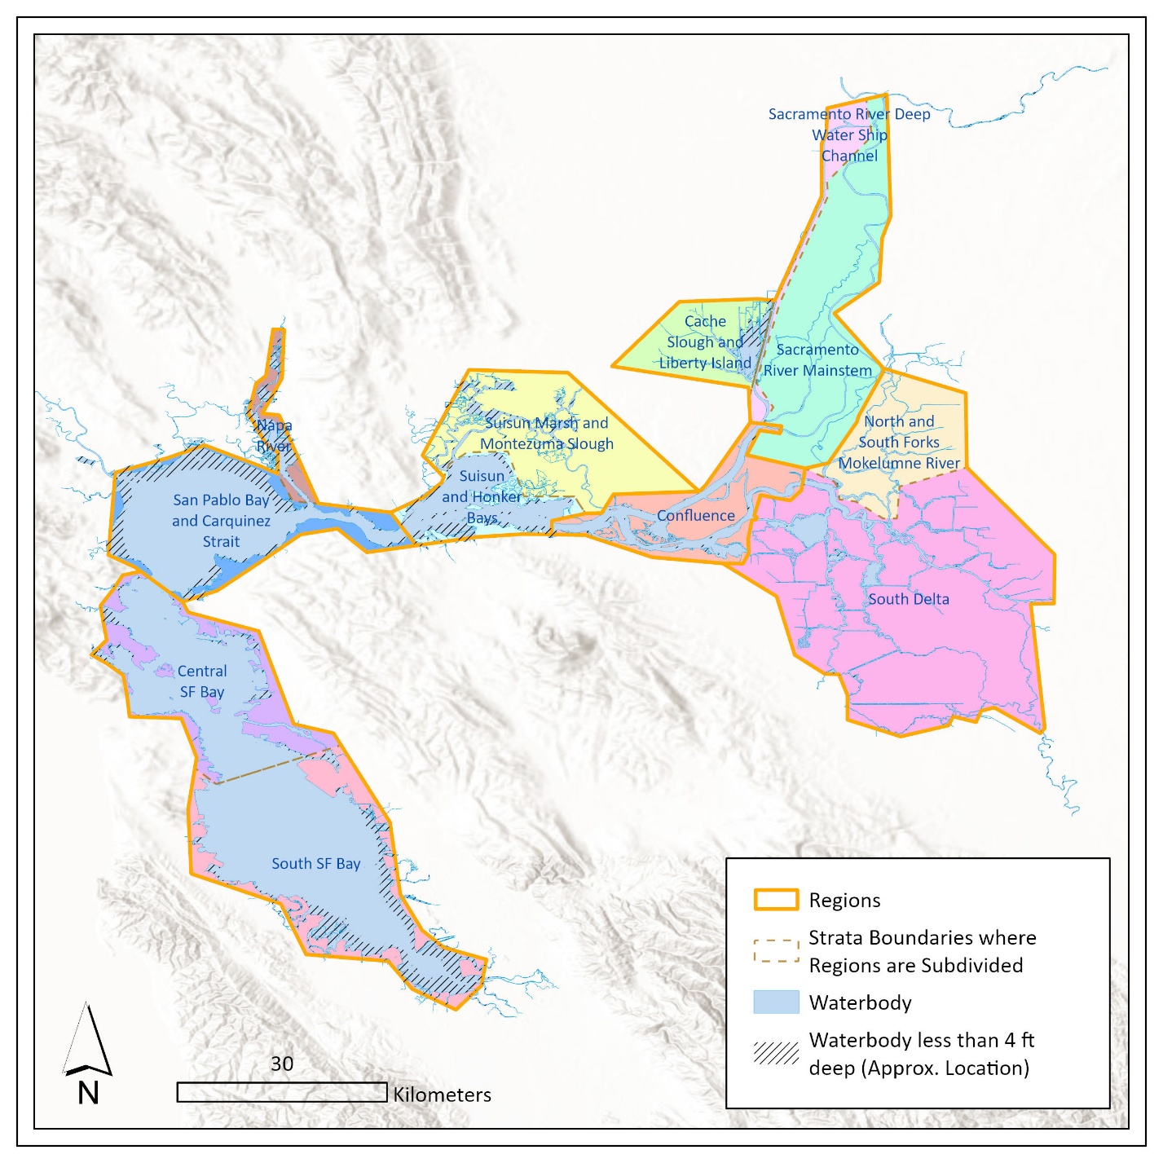

**Figure 2.** Spatial extent showing the exclusion of waters shallower than 4 ft from expansion volumes. The area of waterbody shown without hatching was analyzed to generate mean depth, surface areas, and volumes. Strata are depicted with differing fill colors. See Appendix A for smaller scale maps depicting the inaccessible water and analysis footprint for each stratum and subregion.

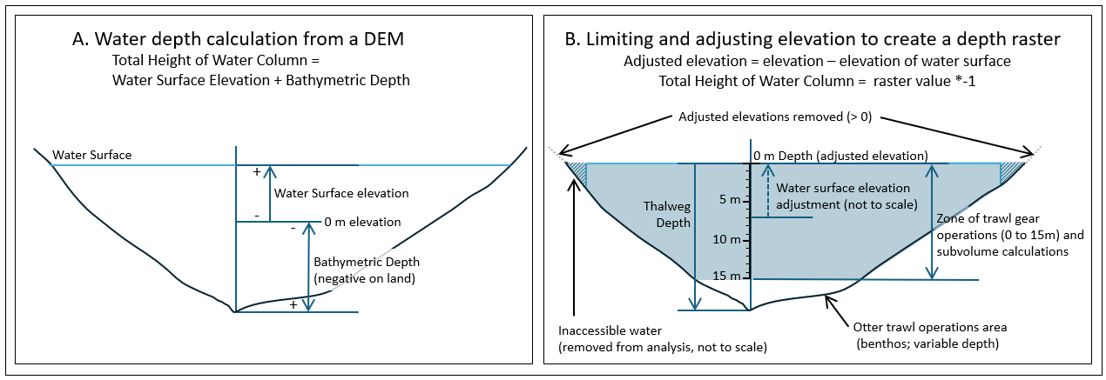

**Figure 3.** Conceptual model of waterbody profile, including parameters used to calculate depth from (A) a digital elevation model and (B) and a from an adjusted elevation depth raster with zones of gear operations.

# Assumptions

There are several notable assumptions that readers should be aware of when interpreting the methods applied in this technical note. Firstly, the MTL adjustments applied to the NAVD 88 elevation reflect approximate local MTL elevations for the San Francisco Bay (1.0 m) and eastward of Carquinez Strait (1.25 m). These adjustments limit the accuracy of the resulting surface areas, depths, and water volumes when applied to areas that experience different mean water surface elevations from the selected values, such as in upstream waters. In the Upper San Joaquin River subregion, the mean water surface elevation has been estimated at 1.6 meters (DWR, 2023), which increases total volume by about 13%. Another possible source of error is that no adjustments of volumes or surface areas have been made for vegetated habitat, an ongoing issue currently affecting the Delta. It is likely that the functioning water volumes in some areas are smaller than the calculated volumes due to areas of tidally inundated marsh, or shallow channels and sloughs filling in with submerged, floating, or emergent aquatic vegetation. Shallow water has functions for monitored species but comprises 1.51% of the total system volume as estimated. Within subregions, water classified as inaccessible (<4 ft) ranged from 69% of total volume (Upper Napa River) to 0.3% (San Joaquin River at Twitchell Island and Central SF Bay), with a mean value of 5% (Table A-1). In the Upper Napa River subregion, only 14% of the waterbody area had an elevation low enough to be classified as accessible with a 1.25 m water surface elevation while in the lower Napa River, 54% of the waterbody area and 89% of the volume were classified as accessible (Table A-1). In the Upper Napa River, the water surface will become steeper as you move upstream, and the 10 m DEM might be too coarse for getting an accurate volume (Sophie Munger, DWR personal communication). By surface area, Suisun Marsh and the Cache Slough and Liberty Island subregions had the highest proportion of inaccessible water outside of the Napa River (48% and 46%, of water surface respectively) while the San Joaquin River at Twitchell Island, Central SF Bay, Franks Tract, and Sacramento River near Rio Vista all had > 95% accessible water by surface area (Table A-1).

Incorporating new data sources will help inform the amount of continuous open water habitat. The availability of higher resolution DEMs, or the use of more spatially dynamic water surface elevations will improve the accuracy of volume and surface area estimates. Estuary-wide data on submerged aquatic vegetation presence could inform reduction of open waters, and ongoing inclusion of new restoration areas or levee breaches (such as Chipps Island) into the waterbody footprint could better account for expansion of water volume by habitat type and quality, adding additional sophistication to future iterations of these methods.

# Acknowledgements

Lara Mitchell and Leo Polansky (USFWS) provided the EDSM polygons and water volumes, and useful discussion that contributed to revisions to this technical note. DWR and USBR funded, supported, and conceptualized this research. Thank you to the IEP scientists who contributed to this research.

# References

Bashevkin SM, Barros A, Hartman R (2024). deltamapr: Spatial Data for the Bay-Delta. R package version 1.0.1, commit fe34697b3d1aaa2945bbfc647582a19e251abf67, https://github.com/InteragencyEcologicalProgram/deltamapr>.

California Department of Water Resources, 2023. Methodology for Flow and Salinity Estimates in the Sacramento-San Joaquin Delta and Suisun Marsh, 44th Annual Progress Report to the State Water Resources Control Board in Accordance with Water Right Decisions 1485 and 1641. https://data.cnra.ca.gov/dataset/methodology-for-flow-and-salinityestimates-in-the-sacramento-san-joaquin-delta-and-suisun-marsh

California Department of Water Resources 2025. *San Francisco Bay and Sacramento-San Joaquin Delta DEM for Modeling, Version 4.3* [Data set]. DWR Bay-Delta Office, Delta Modeling Section. California Natural Resources Agency. https://data.ca.gov/dataset/san-francisco-bay-and-sacramento-san-joaquin-delta-dem-for-modeling-version-4-3

Chadwick, H. K. 1964. Annual abundance of young striped bass, *Roccus saxatilis*, in the Sacramento-San Joaquin Delta, California. California Fish & Game 50: 69-99.

MacWilliams, M. L., Bever, A. J., Gross, E. S., Ketefian, G. S., and Kimmerer, W. J. 2015. Three-Dimensional Modeling of Hydrodynamics and Salinity in the San Francisco Estuary: An Evaluation of Model Accuracy, X2, and the Low-Salinity Zone. San Francisco Estuary Watershed and Science 13(1). doi: <http://dx.doi.org/10.15447/sfews.2015v13iss1art2>

Mitchell, L., Polansky, L., Newman, K.B., 2018. DSM TN 2. Design-based Estimates of Delta Smelt Abundance.

Monitoring Survey Design Team. 2022. Evaluation and Analysis of Five Long-Term Biological Monitoring Studies in the Upper San Francisco Estuary. Report prepared for the 6 Agency Steering Committee. 176 pages. <https://csamp.baydeltalive.com/docs/25928>

Polansky, L., Studen, L., 2019. DSM TN 29. Water volumes of the San Francisco Estuary in Areas Occupied by Delta Smelt. February 27th, 2019 DRAFT.

Slater SB, Barros A, Melwani AR. 2023. CDFW Methods for Defining Sample Frame, Stratification, and Volumes for Juvenile Pelagic Fishes Studies in the Upper San Francisco Estuary. Monitoring Survey Design Technical Note #1. DRAFT FOR 6-AGENCY REVIEW. January 12, 2023. California Department of Fish and Wildlife.

U.S. Fish and Wildlife Service, 2025. National Wetland Inventory, NWI, access date 4/10/2025. <https://www.fws.gov/program/national-wetlands-inventory/download-state-wetlands-data>

# **Appendix A. Volume estimation analysis maps by subregion**

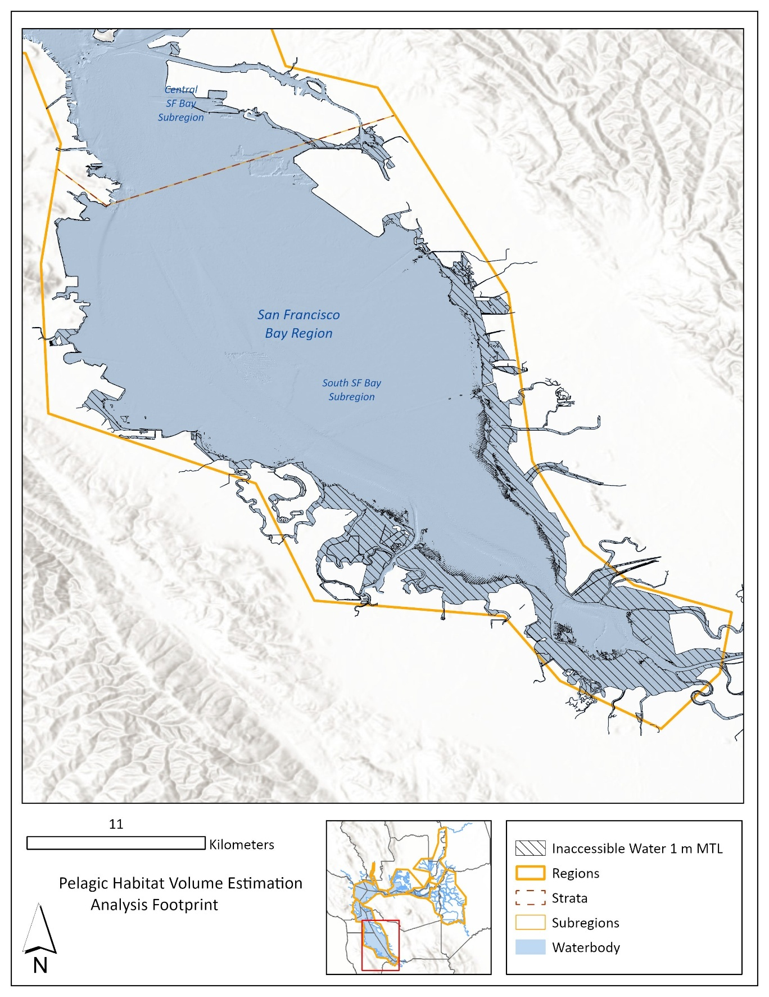 Figure A-1. Analysis map of South San Francisco Bay with the full waterbody and inaccessible water.

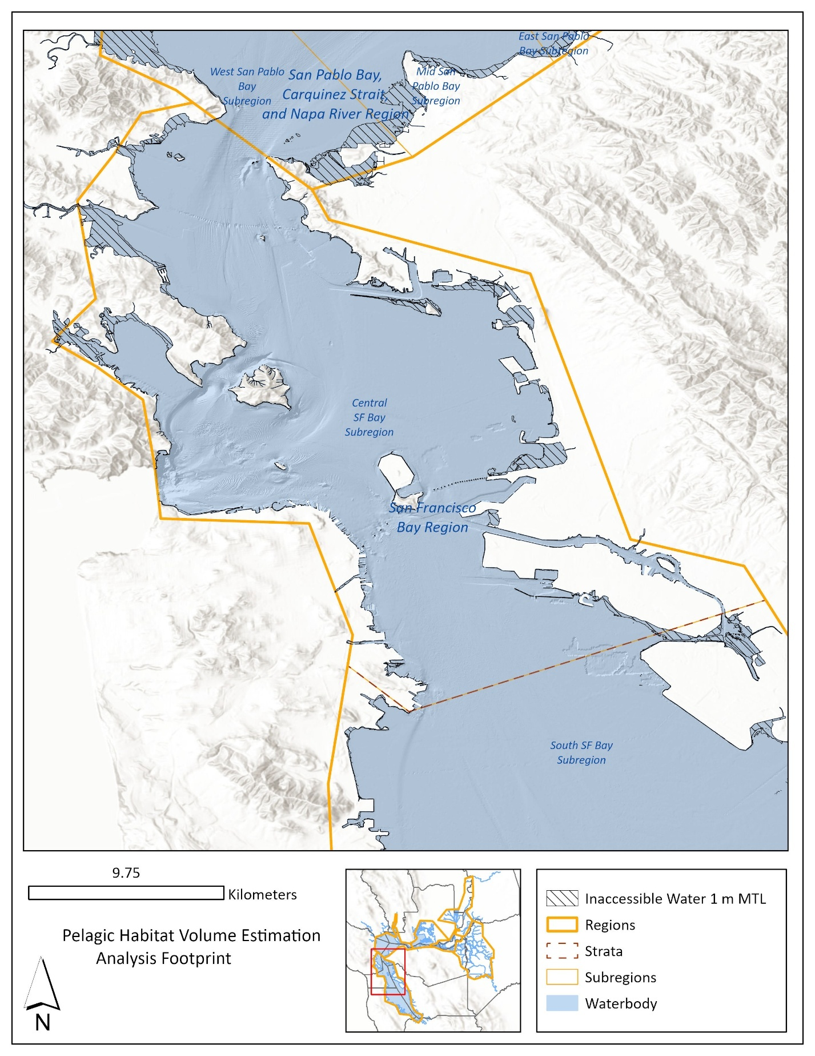 Figure A-2. Analysis map of Central San Francisco Bay with the full waterbody and inaccessible water.

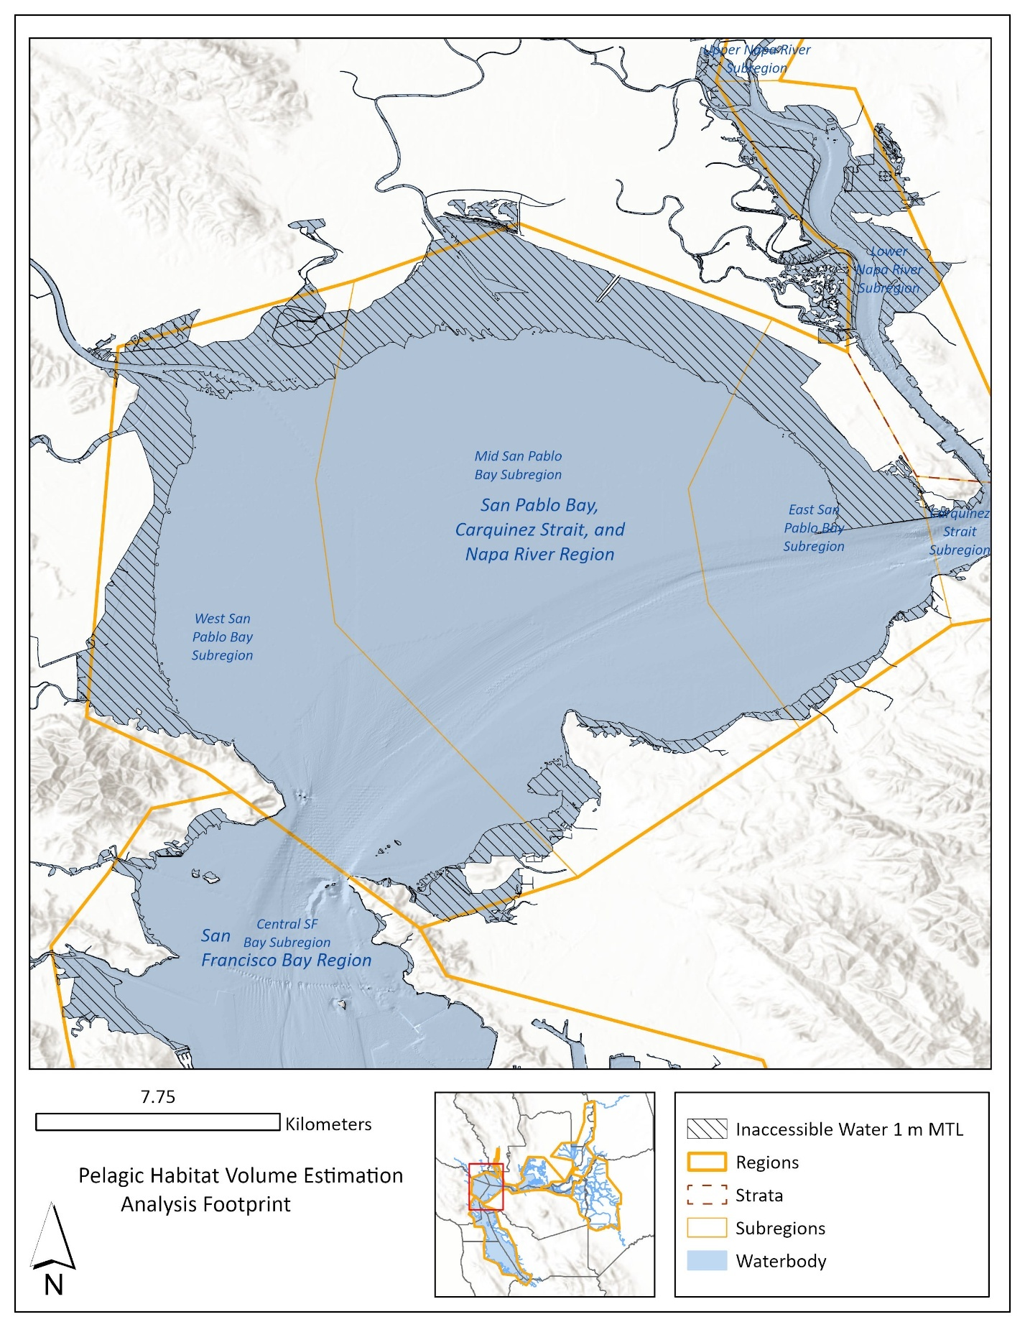

Figure A-3. Analysis map of San Pablo Bay with the full waterbody and inaccessible water.

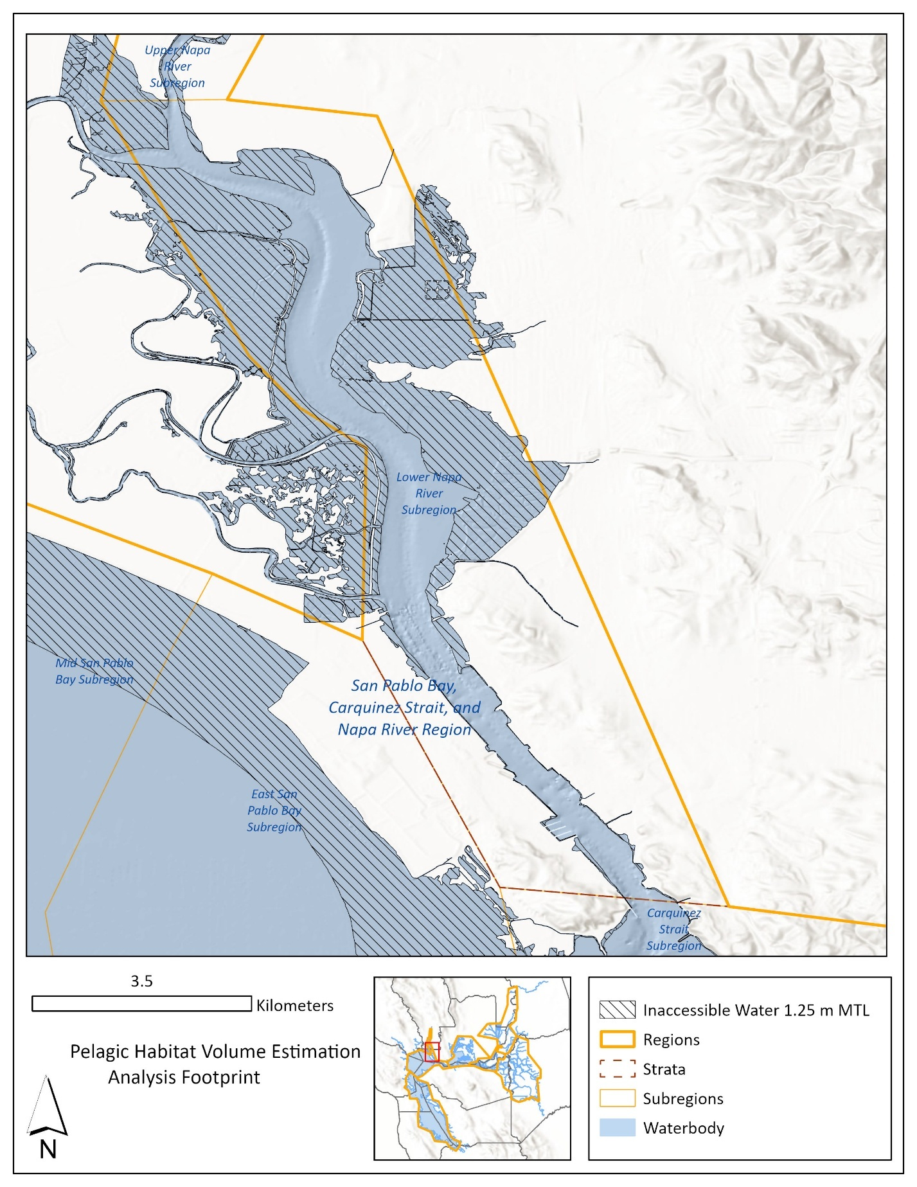Figure A-4. Analysis map of Lower Napa River with the full waterbody and inaccessible water.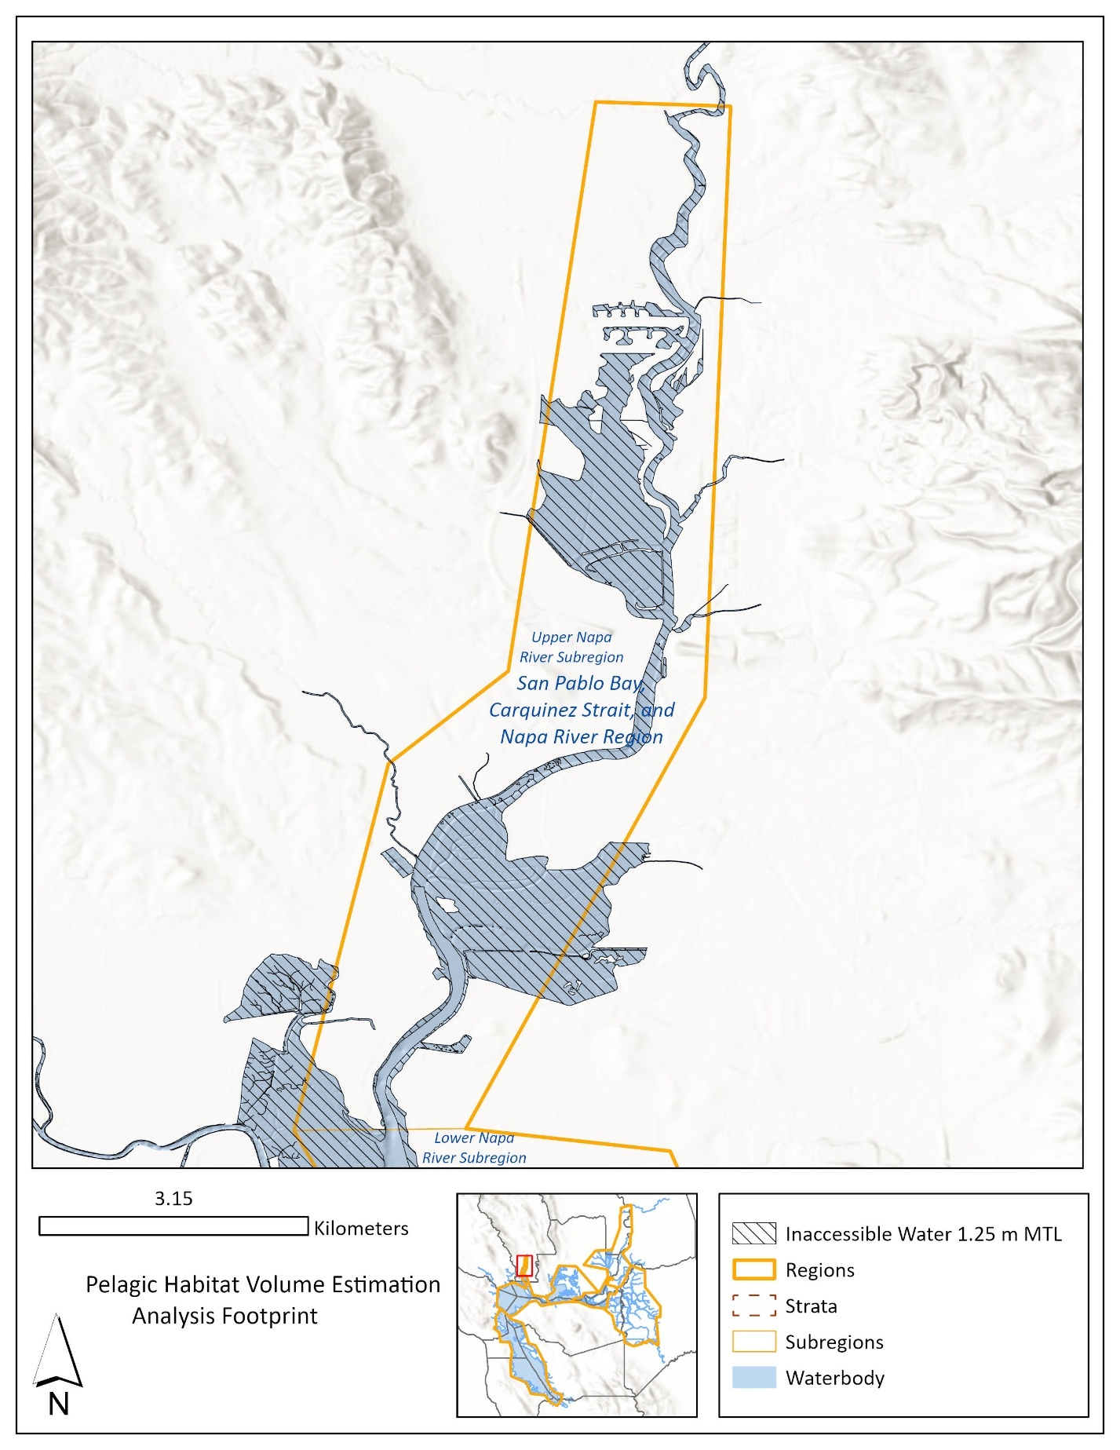Figure A-5. Analysis map of Upper Napa River with the full waterbody and inaccessible water.

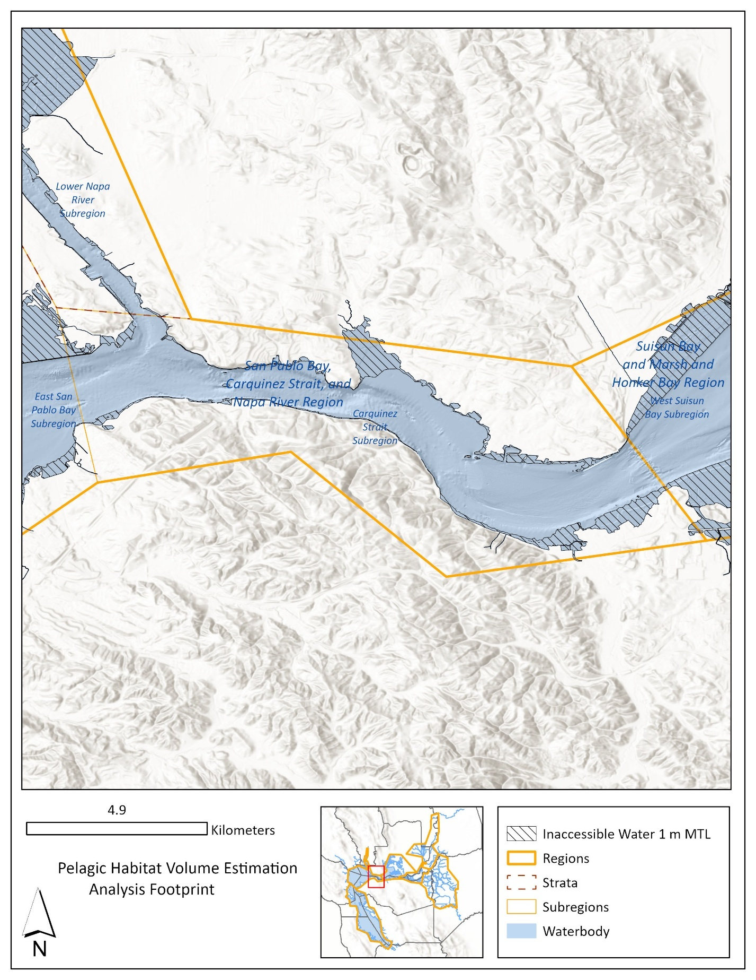Figure A-6. Analysis map of Carquinez Strait with the full waterbody and inaccessible water.

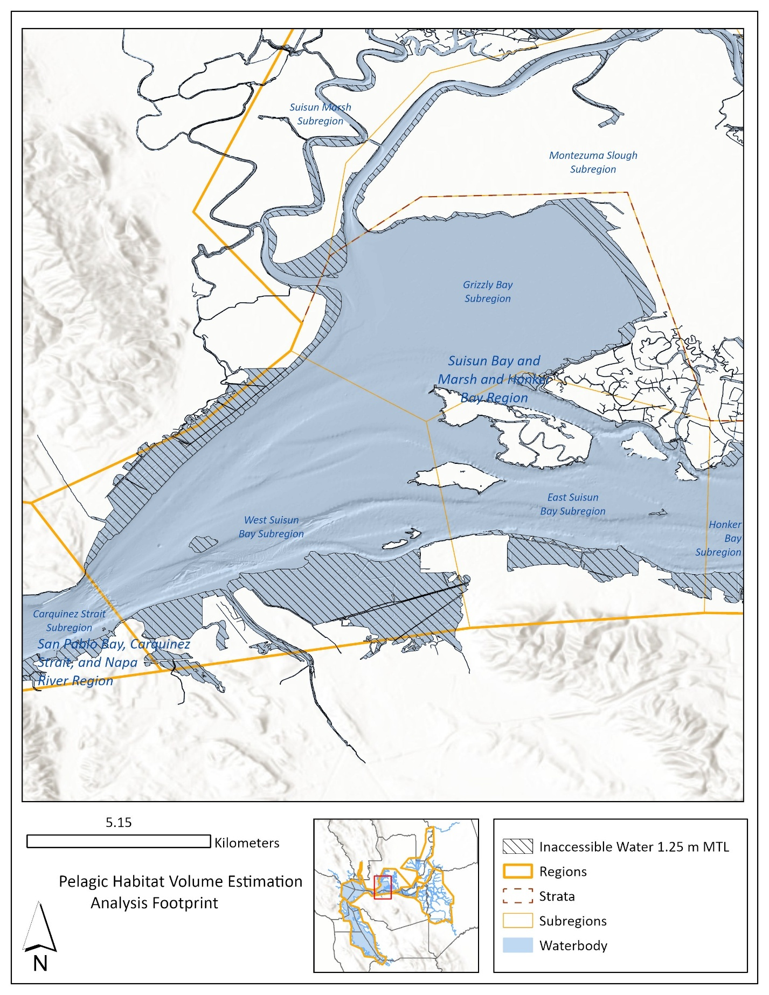Figure A-7. Analysis map of Suisun Bay with the full waterbody and inaccessible water.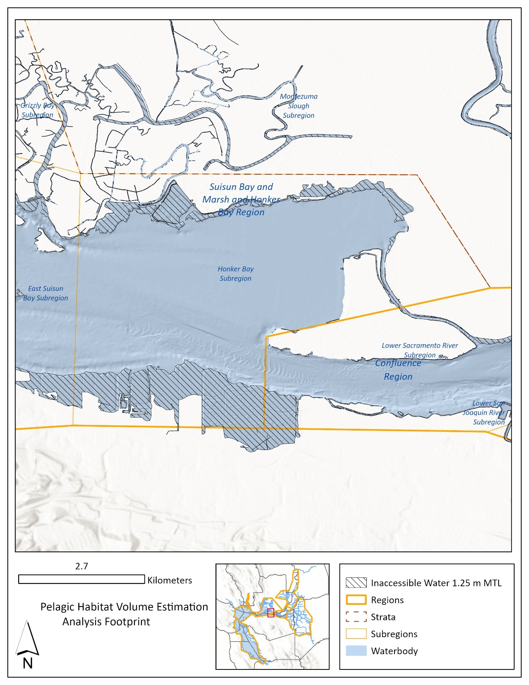Figure A-8. Analysis map of Honker Bay with the full waterbody and inaccessible water.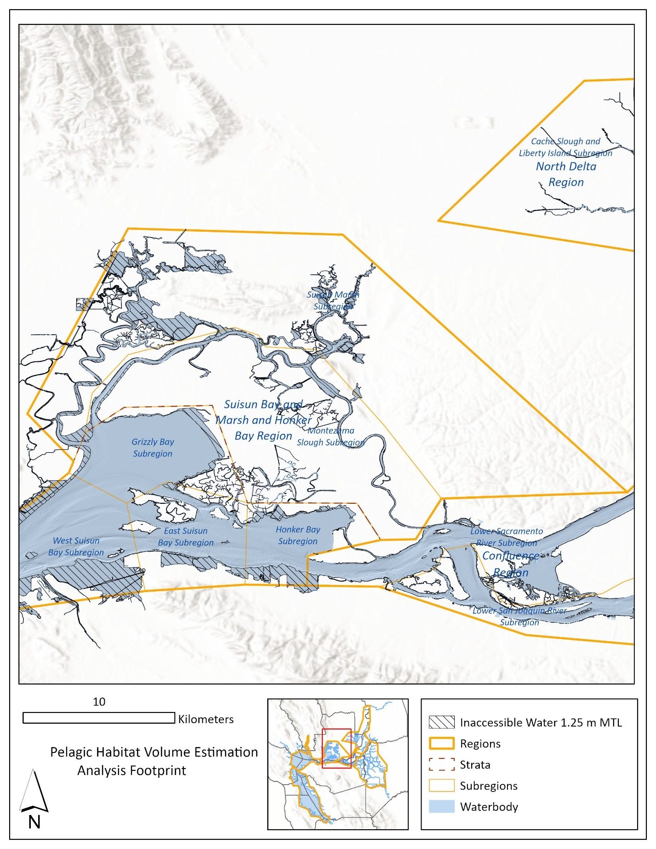Figure A-9. Analysis map of Suisun Bay and Marsh and Honker Bay with the full waterbody and inaccessible water.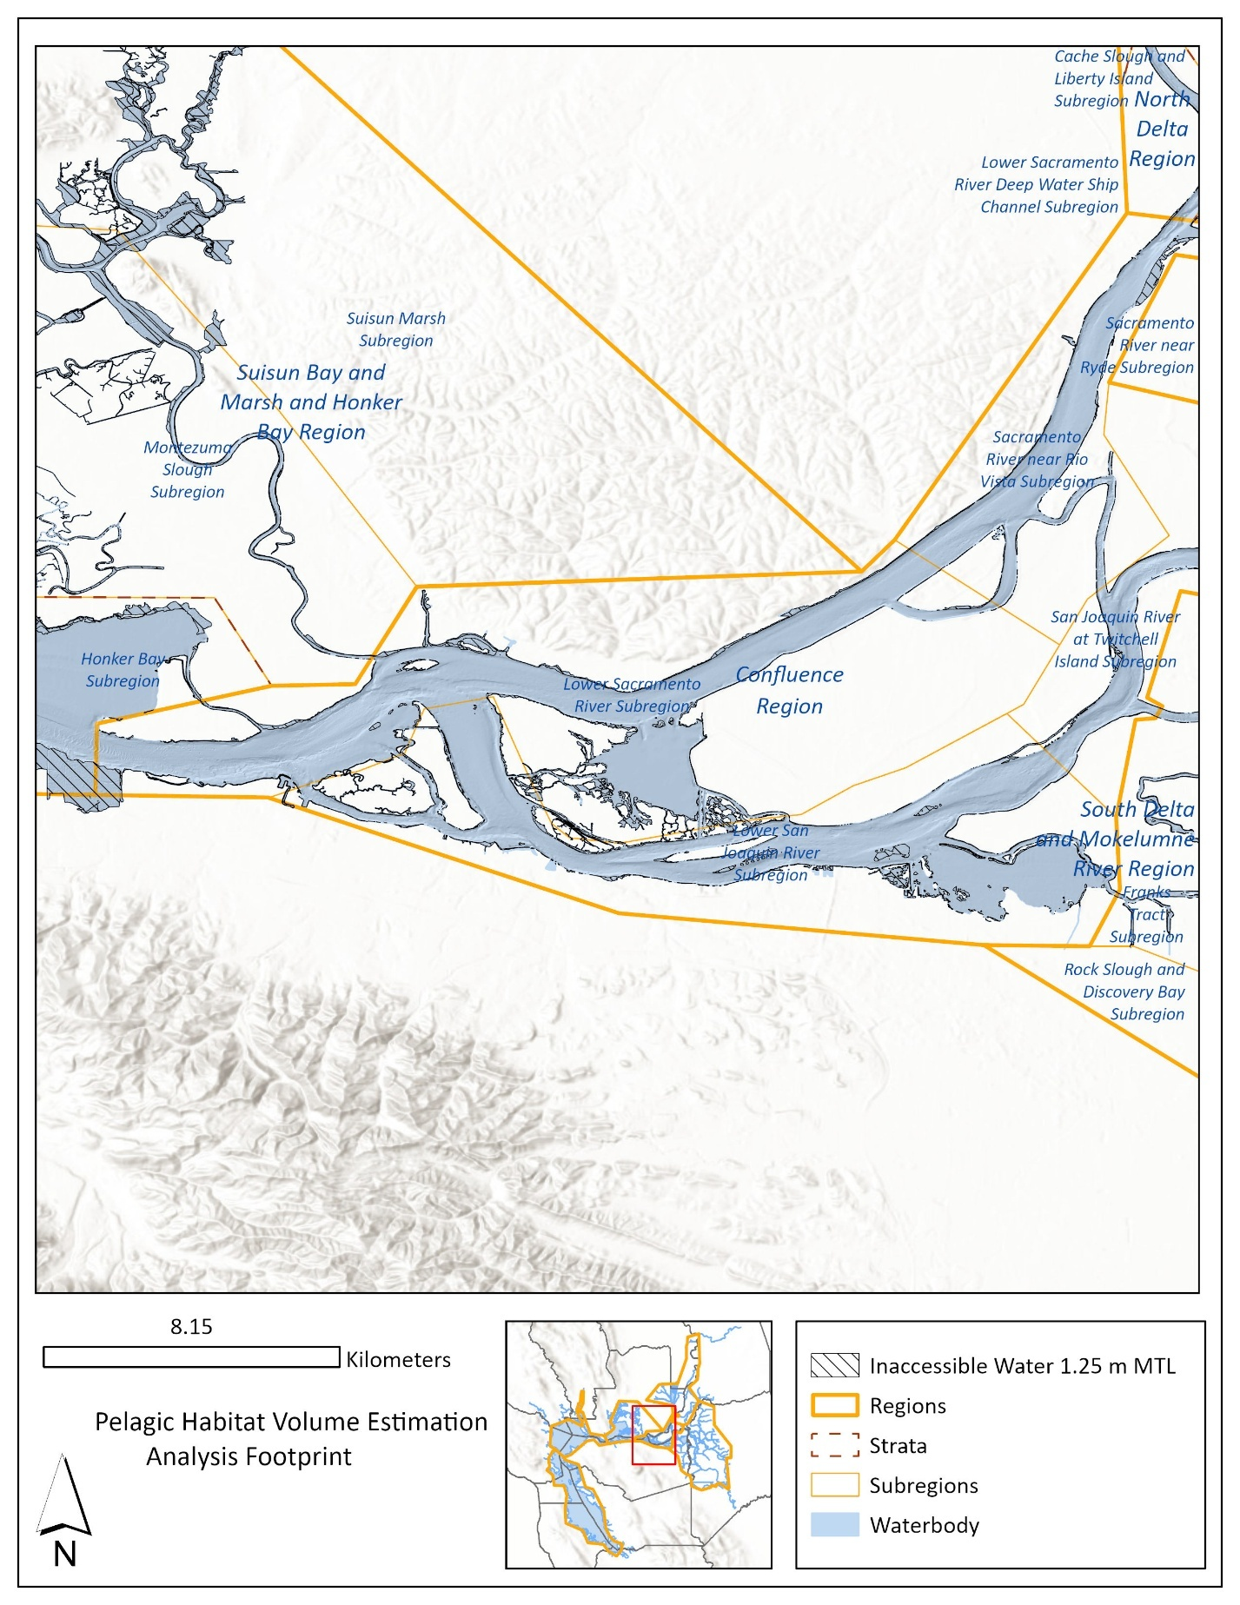Figure A-10. Analysis map of the Confluence with the full waterbody and inaccessible water.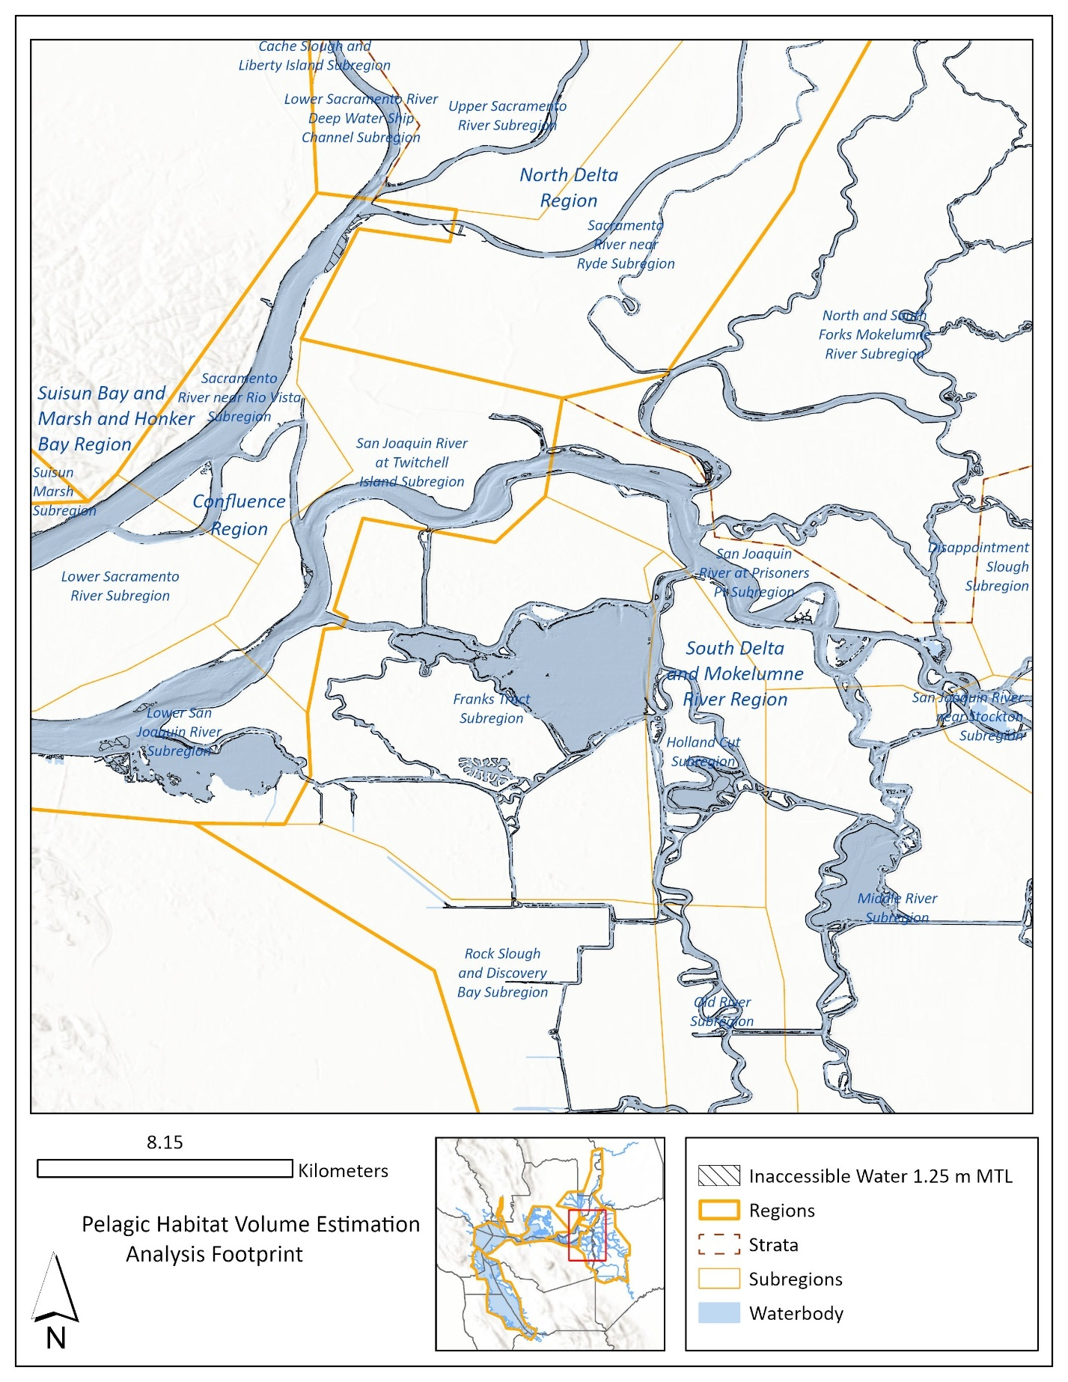Figure A-11. Analysis map of the central Delta with the full waterbody and inaccessible water.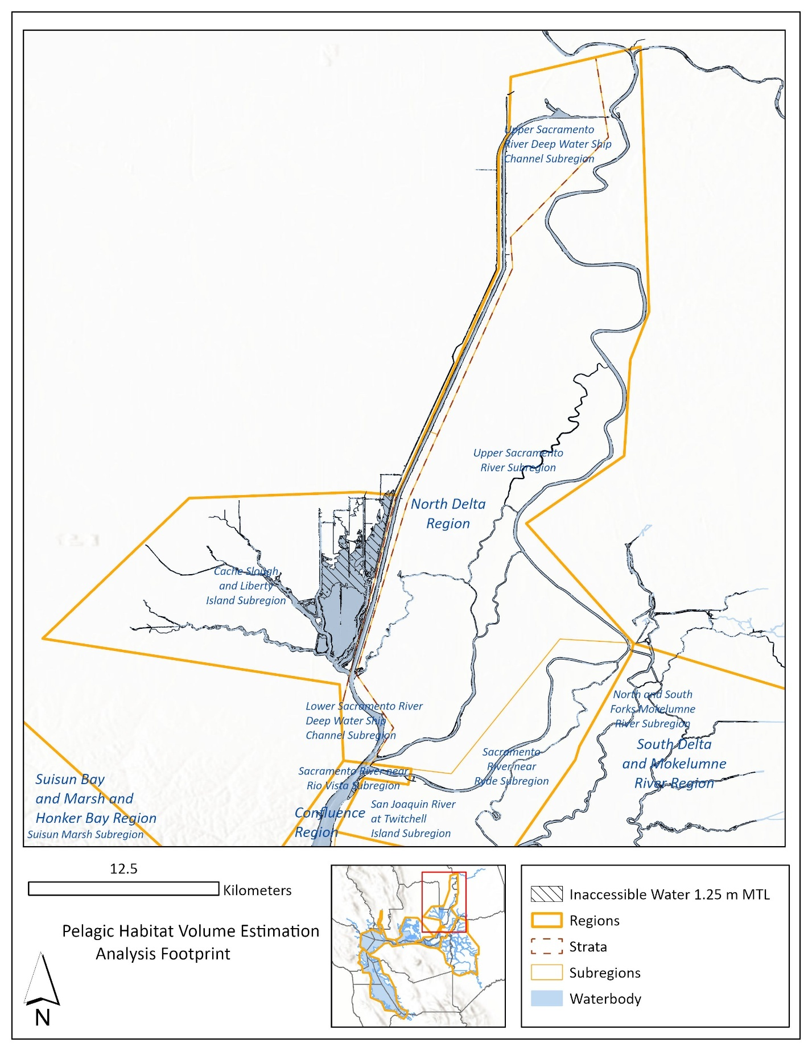Figure A-12. Analysis map of the North Delta with the full waterbody and inaccessible water.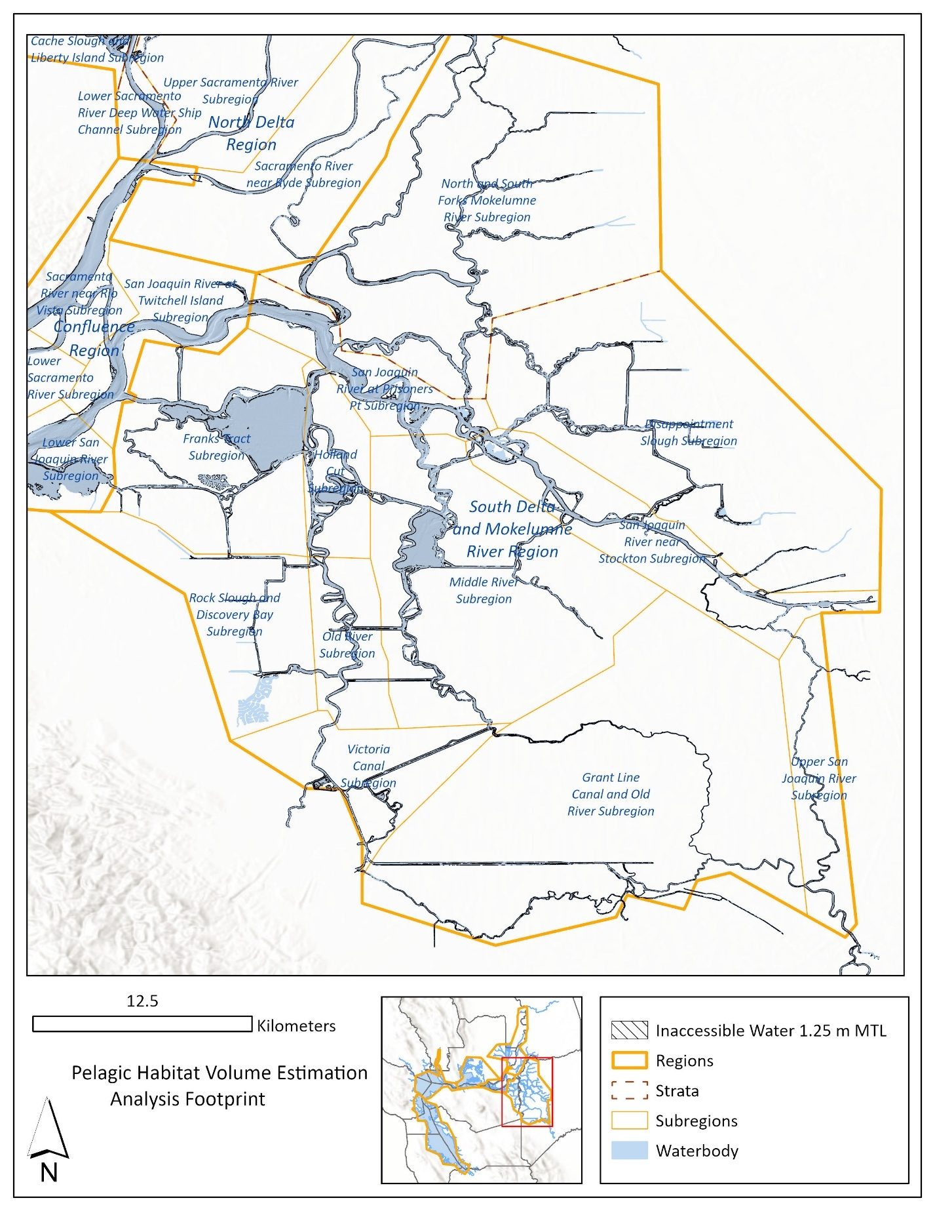Figure A-13. Analysis map of the South Delta with the full waterbody and inaccessible water.

Table A-1. Total volume (km3) and surface area (km2) of the waterbody contained in the sample frame, and percent of total volume and surface area categorized as inaccessible.

|  |  |  |  |  |  |  |  |
| --- | --- | --- | --- | --- | --- | --- | --- |
| Subregion Order | Subregion | Total Volume of Waterbody (km3) | Total Accessible Volume (km3) | Total Surface Area of Waterbody (km3) | Total Accessible Surface Area (km3) | Inaccessible Volume as Percent of Total Volume | Inaccessible Surface Area as Percent of Total Surface Area |
| 1 | South SF Bay | 1.9096 | 1.8657 | 420.9914 | 364.2053 | 2.2956 | 13.4887 |
| 2 | Central SF Bay | 3.2064 | 3.1965 | 280.9318 | 268.5202 | 0.3097 | 4.4180 |
| 3 | West San Pablo Bay | 0.3469 | 0.3325 | 90.5189 | 72.3761 | 4.1632 | 20.0431 |
| 4 | Mid San Pablo Bay | 0.4897 | 0.4753 | 138.6495 | 120.5725 | 2.9362 | 13.0379 |
| 5 | East San Pablo Bay | 0.1734 | 0.1693 | 40.1308 | 33.8665 | 2.3984 | 15.6097 |
| 6 | Carquinez Strait | 0.2700 | 0.2681 | 22.1146 | 19.8558 | 0.6752 | 10.2141 |
| 7 | Lower Napa River | 0.0411 | 0.0365 | 16.2128 | 8.6984 | 11.3688 | 46.3486 |
| 8 | Upper Napa River | 0.0020 | 0.0006 | 2.762 | 0.391 | 68.9592 | 85.8436 |
| 9 | West Suisun Bay | 0.1902 | 0.1887 | 33.3192 | 30.9644 | 0.7610 | 7.0674 |
| 10 | East Suisun Bay | 0.1135 | 0.1127 | 18.9031 | 17.7287 | 0.7358 | 6.2127 |
| 11 | Honker Bay | 0.0741 | 0.0735 | 16.3758 | 15.4546 | 0.7524 | 5.6254 |
| 12 | Grizzly Bay | 0.0814 | 0.0801 | 30.7513 | 28.8701 | 1.5749 | 6.1175 |
| 13 | Montezuma Slough | 0.0358 | 0.0335 | 8.843 | 5.5772 | 6.4167 | 36.9309 |
| 14 | Suisun Marsh | 0.0202 | 0.0172 | 9.5618 | 4.9254 | 14.4555 | 48.4888 |
| 15 | Lower Sacramento River | 0.2261 | 0.2245 | 30.7654 | 28.258 | 0.7258 | 8.1501 |
| 16 | Sacramento River near Rio Vista | 0.0753 | 0.0750 | 11.3072 | 10.7557 | 0.4042 | 4.8774 |
| 17 | Lower San Joaquin River | 0.1535 | 0.1521 | 26.9747 | 24.9589 | 0.9173 | 7.4729 |
| 18 | San Joaquin River at Twitchell Island | 0.0818 | 0.0816 | 9.0722 | 8.6938 | 0.3009 | 4.1710 |
| 19 | Cache Slough and Liberty Island | 0.0546 | 0.0474 | 24.1956 | 14.9355 | 13.1656 | 38.2718 |
| 20 | Lower Sacramento River Deep Water Ship Channel | 0.0425 | 0.0422 | 5.2562 | 4.8188 | 0.7654 | 8.3216 |
| 21 | Upper Sacramento River Deep Water Ship Channel | 0.0325 | 0.0319 | 4.8704 | 4.123 | 1.6517 | 15.3458 |
| 22 | Upper Sacramento River | 0.0622 | 0.0615 | 12.8275 | 11.7274 | 1.1110 | 8.5761 |
| 23 | Sacramento River near Ryde | 0.0185 | 0.0184 | 3.7901 | 3.5279 | 0.8341 | 6.9180 |
| 24 | North and South Forks Mokelumne River | 0.0543 | 0.0534 | 12.2383 | 10.803 | 1.6147 | 11.7279 |
| 25 | San Joaquin River at Prisoners Pt | 0.0812 | 0.0808 | 11.9879 | 11.3779 | 0.4420 | 5.0885 |
| 26 | Franks Tract | 0.0708 | 0.0702 | 21.2485 | 20.285 | 0.9490 | 4.5344 |
| 27 | San Joaquin River near Stockton | 0.0429 | 0.0425 | 7.2164 | 6.5123 | 1.0346 | 9.7569 |
| 28 | Holland Cut | 0.0300 | 0.0295 | 6.7357 | 5.9016 | 1.6982 | 12.3833 |
| 29 | Old River | 0.0145 | 0.0143 | 3.3429 | 2.9114 | 1.6985 | 12.9080 |
| 30 | Middle River | 0.0664 | 0.0658 | 13.6133 | 12.6494 | 0.9568 | 7.0806 |
| 31 | Victoria Canal | 0.0113 | 0.0107 | 3.1734 | 2.2939 | 5.4170 | 27.7148 |
| 32 | Upper San Joaquin River | 0.0047 | 0.0045 | 1.6339 | 1.3536 | 3.7590 | 17.1553 |
| 33 | Disappointment Slough | 0.0188 | 0.0182 | 6.3083 | 5.3667 | 3.4446 | 14.9264 |
| 34 | Grant Line Canal and Old River | 0.0104 | 0.0094 | 4.5768 | 3.0911 | 9.3449 | 32.4615 |
| 35 | Rock Slough and Discovery Bay | 0.0047 | 0.0045 | 1.7725 | 1.4908 | 4.5828 | 15.8928 |
| - | TOTAL | 8.1114 | 7.9886 | 1352.9732 | 1187.8419 | 1.5143 | 12.2051 |

# Appendix B. Waterbody delineation methods

## Introduction

This appendix outlines the Design Team methodology for delineating the SFE through combining elevation-based analysis of bathymetry with National Wetlands Inventory (NWI) data (USFWS, 2025). The methodology was based on the USFWS process that was used to generate expansion volumes for calculating abundance indices in the EDSM Program (Polansky and Stunden 2019). However, key differences from the USFWS approach described here are the inclusion of selected riverine and lake polygons from the NWI, and the inclusion of untrimmed estuarine/marine wetlands to better capture the complex hydrology of the Delta. All work was performed in ArcGIS Pro version 3.3.

## Summary

The process began with using the highest subregional mean water surface elevation that fell within the Design Team sample frame as a threshold to filter bathymetry data and create an initial elevation-based waterbody polygon. This coarse waterbody was then utilized to inform the filtering and spatial analysis of NWI data. The process emphasized visual inspection to ensure accuracy and appropriate site classification.

The product is essentially a highly customized filter of NWI data. All estuarine and marine wetland areas from South San Francisco Bay and upstream to the confluence of the Sacramento and San Joaquin rivers were retained, except for a few large islands. Further inland through the legal Delta, riverine, lake, and pond wetland types were selectively included if they intersected the elevation-based waterbody. Non-overlap with the “deltamapr” (Bashevkin et al. 2024) waterways layer was used to inform exclusion irrelevant features. The process explicitly removed off-channel and non-pelagic wetland types, while making exceptions for specific features that visually indicated riverine or hydrological connectivity with the main pelagic waterbody. The final product consisted of 58% fewer distinct polygons compared to the USFWS procedure.

## Steps in ArcGIS Pro

1. DETERMINE WATER SURFACE ELEVATION AND REMOVE LAND:
   1. We extracted a mean water surface elevation value in NAVD 88 for each subregion based on the 10-year mean water surface elevation points within the sample frame (DWR, 2023).
   2. We identified the highest subregional mean water surface elevation (Upper Sacramento River, 187 cm) and removed all elevations greater than or equal to 187 cm from the 2025 bathymetry.
2. SELECT THE MAIN ELEVATION-BASED WATERBODY:
   1. We generated low-lying area polygons from the filtered bathymetry by running the Raster to Polygon tool (with simplification allowed).
   2. We then selected the largest continuous area to be the elevation-based waterbody and included any nearby low-lying areas within 5 meters for consideration.
3. SPATIALLY QUERY THE NATIONAL WETLANDS INVENTORY (NWI) AND LIMIT EXTENTS:
   1. We selected NWI features falling partially or fully within the sample frame for initial inclusion (n = 19,989 polygons).
   2. We then removed areas west of the Golden Gate from the NWI query and the elevation-based waterbody.
4. CREATE A UNION OF NWI AND THE ELEVATION-BASED WATERBODIES TO ENABLE SELECTION AND VISUAL INSPECTION OF NWI:
   1. We dissolved the NWI query into a single multi-part polygon per Wetland Type, then performed a Union with the elevation-waterbody.
   2. We delineated the area of agreement between NWI and the waterbody, and the areas unique to the elevation-based waterbody only or NWI only.
   3. These features were used for decision-making during visual inspection of data. First, polygon area was utilized to sort and clean the union i.e. deleting polygons with zero area (geometry artifacts). All polygons within the area of waterbody-NWI agreement at least one square kilometer in size were individually visually examined and given site names and notes in the spatial data. This layer was used to make selections in step six below (selecting NWI features for inclusion).
5. RETAIN ESTUARINE AND MARINE NWI WETLAND TYPES:
   1. We used a definition query to include ‘Estuarine and Marine Deepwater’, and ‘Estuarine and Marine Wetland’ wetland types.
   2. Exceptions to this were large islands in Suisun and Honker Bays that were removed despite being classified as ‘Estuarine and Marine Wetland’. The marine wetland islands removed included Row Island, Ryer Island, Seal Islands, and Chipps Island. From Brown’s Island upstream, islands in the NWI are classified as other types of wetlands (Emergent Freshwater, Pond etc.) and were excluded from the waterbody via the subsequent procedures.
6. SELECT A SUBSET OF RIVERINE, LAKE AND POND WETLAND TYPES USING THE ELEVATION-BASED WATERBODY: In the eastern Delta, beyond the extent of Estuarine wetland types, select from Riverine and Lake wetland polygons for inclusion.
   1. All riverine polygons that intersected the elevation-based waterbody were initially retained. However, following review, this process was found to include many agricultural channels in low-lying areas that are not of interest for habitat volume estimation (notably in Suisun Marsh). To limit the inclusion of channels to those most relevant to volume estimation, the selected Riverine polygons were further limited to those intersecting the deltamapr waterways layer. Riverine polygons intersecting the low-lying areas within 5 meters of the elevation-based waterbody were found to be mainly linear (agricultural) channels adjacent to, but outside of the area of interest and were therefore excluded.
   2. Lake polygons that did not intersect the elevation-based waterbody or the low-lying areas within 5 meters of it were removed. Lakes that intersected the main waterbody or low-lying areas within 5 meters were visually inspected in comparison to aerial imagery, bathymetry, and deltamapr waterways to determine inclusion. Many lakes in the Suisun Marsh area were excluded based on this review.
   3. Lakes that were removed despite their overlap with the deltamapr waterways include Willow Lake in Discovery Bay, and Clifton Court Forebay (CCF). CCF was excluded, because it is outside the sample frame. Lakes intersecting deltamapr were visually inspected and several of these which were spatially distinct (hydrologically disconnected) areas delineated in deltamapr were not included.
   4. Of note, Liberty Island, which is largely classified as lake wetland is not depicted in deltamapr and was retained.
   5. Pond polygons that intersected the elevation-based waterbody, (n = 1,335 ponds) were visually inspected if > 3 acres in size. Ponds that intersected deltamapr waterways additionally (n = 74) were visually inspected in reference to imagery, bathymetry, and adjacency to polygons already selected for inclusion. Ponds that appeared to be >50% surface water and hydrologically connected to the main waterbody were retained.
7. REMOVE OFF-CHANNEL AND NON-PELAGIC NWI WETLAND TYPES: All polygons of wetland types ‘Freshwater Emergent Wetland’, ‘Freshwater Forested/Shrub Wetland’, and ‘Other’ were removed after visually inspecting their intersections with the main waterbody.
8. ADD BACK MISSING OR ERRONEOUSLY EXCLUDED AREAS:
   1. One freshwater emergent wetland polygon was re-included in the area east of the town of Mountain House, as it appeared to be riverine.
   2. One polygon was drawn in where a data gap was found along the southern shore of Suisun Bay.
9. EXPORT AND DISSOLVE THE FILTERED NWI WETLAND FEATURES:
   1. The initial resulting data ‘DesignTeam_Waterbody_Wetlands’ had 5,180 unique polygons with Wetland Type and notes about reason for inclusion.
   2. Attempting to create a single polygon representing the waterbody, we dissolved the ‘DesignTeam_Waterbody_Wetlands’ layer, initially resulting in 106 single-part polygons
   3. Four of these disconnected polygons were found to be fully outside of the planned depth masks and were removed so as not to be included in the volume estimations, before repeating the Dissolve. This resulted in a reduction of polygons in ‘DesignTeam_Waterbody_Wetlands’ to 102 geometrically distinct polygons with no attributes in the ‘DesignTeam_Waterbody_SingleParts’. In contrast, the USFWS water footprint includes 175 geometrically distinct polygons.
   4. Finally, a single multi-part polygon feature was created to represent the hydrological footprint to be used in the volume estimates by running a Dissolve with multi-part features allowed to create the ‘DesignTeam_Waterbody’. The use of a single multipart feature is consistent with USFWS procedure.

# Appendix C. Volume estimation procedure

## Introduction

The following R code, “terra_volume_calcs.R”, was used to estimate mean depth, surface area, and volume of accessible pelagic habitat within the sample frame. This script was originated by Arthur Barros in January of 2024 and has been adjusted, corrected, and annotated by Celeste Dodge.

Outputs of this script include:

* **About_WaterSurfaceElevation.csv**: Water Elevations documentation
* **terra_volumes_report_tab.csv**: the primary product for use in calculating design-based abundance estimates. Includes subregional mean depth, surface area, total volume, and volume in top 10 meters and top 2 meters of water, with agreed upon selection of 1.25 and 1 m water elevation settings.
* **terra_volumes_long.csv** Long data for analysis. Includes all water elevations
* **terra_volumes_X.csv**: raw 1 m slice volumes per water surface elevation (WSE)

## Volume Estimation R Script

# Purpose: Six-Agency Design Team - terra Volume calculations for horizontal depth slices  
# Date: November 18th, 2025  
# Author: Celeste Dodge, adapted from methods developed by Arthur Barros (January 2024)  
  
  
#_____Steps:________________________  
#__________Step 1________ Prep Env ________________  
#__________Step 2________ Load Data ________________  
#__________Step 3________ Set Elevation Parameters and Prep Data ________________  
#__________Step 4________ Prep Data and calculate subregion area, depth and volume statistics ________________  
#___________Step 4.1_____ Calculate subregion volume in slices, mean depth, total volume and surface area   
#__________Step 5________ Repeat Calculations for Strata and Regions ________________  
#__________Step 6________ Create primary table products ________________  
#__________Step 7________ Save Outputs ________________  
  
#__________Step 1________ Prep Env ________________  
library(dplyr)  
library(sf)  
library(terra)  
  
#__________Step 2________ Load Data ________________  
# Hydro footprint spatial extent  
Waterbody <- st_read("data/spatial/DesignTeam_Waterbody_NAD83_utm.shp") # 2025 waterbody projected to DEM spatial reference  
# for USFWS waterbody projected to DEM spatial reference  
# Waterbody <- st_read("data/spatial/USFWS water_footprint_NAD83_utm.shp")  
  
# Subregions  
SRs <- st_read("data/spatial/Design_Subregions_NAD83_utm.shp") # 2025 subregions projected to DEM spatial reference  
SRs <- SRs[SRs$SubRegion != "Out of Bounds",]  
# SRs <- st_read("data/spatial/fmwt_regions.shp") # original subregions  
# SRs <- st_read("data/spatial/fmwt_regions_contiguous.shp") # 2024 subregions  
  
# Strata and Regions projected to DEM spatial reference  
Strata <- st_read("data/spatial/Design_Strata_NAD83_utm.shp")  
Strata <- Strata[Strata$Stratum != "Out of Bounds",]  
Regions <- st_read("data/spatial/Design_Regions_NAD83_utm.shp")  
Regions <- Regions[Regions$Region != "Out of Bounds",]  
  
# for historical subregions  
#SRs <- st_read("data/spatial/Historical_SampleFrame_NAD83_utm.shp") # 2025 subregions projected to DEM spatial reference  
#names(SRs)[2] <- "SubRegion"  
  
# Load 2025 bathymetry, all bathymetry is in the NAVD88 vertical datum. Download here:

# https://data.cnra.ca.gov/dataset/san-francisco-bay-and-sacramento-san-joaquin-delta-dem-for-modeling-version-4-3  
depth_raster <- rast("C:/Users/CDodge/OneDrive - California Department of Fish and Wildlife/DATA/USGS_Bathymetry/2025/dem_bay_delta_10m_20250312.tif")  
# To change DEM, find and replace file name "dem_bay_delta_10m_20250312" in code below (raster name is a field below in three locations)  
  
#__________Step 3________ Set Elevation Parameters and Prep Data ________________  
# Set known min and max elevations of MLLW and MTL across SFE (NOAA) and combine with approx values  
WaterElevations <- data.frame(cbind(c("Redwood City MLLW", "Port Chicago MLLW", "Redwood City MTL", "Port Chicago MTL", "SF MHHW", "Redwood City MHHW","Approx MLLW", "Approx MTL in SF Bay", "USFWS Antioch MTL and Prior Standard"),  
 c(-0.36, 0.335, 0.976, 1.119, 1.798, 2.14, 0, 1, 1.25)))

# set depth criteria to filter out shallow depths  
MinDepth <- 1.2192  
  
# For Historical run:  
#WaterElevations <- data.frame(cbind(c("Redwood City MLLW - lowest known MLLW", "Port Chicago MLLW - highest known MLLW", "Approx MLLW", "Average elevation of 0 meters NGVD 29", "Approx MTL in SF Bay","USFWS Antioch MTL and Prior Standard"),c(-0.36, 0.335, 0, 0.82296, 1, 1.25)))  
#names(WaterElevations) <- c("Description","ElevationNAVD88_m")  
#MinDepth <- 0.9144  
  
names(WaterElevations) <- c("Description","ElevationNAVD88_m")  
# Initialize various water elevations and to examine water elevation and tidal range impacts  
WaterElevs <- sort(as.numeric(WaterElevations$ElevationNAVD88_m))  
  
#__________Step 4________ Calculate subregion area, depth and volume statistics ________________  
# Remove raster values outside of polygon footprint  
raster_mask <- mask(depth_raster,Waterbody)  
  
for(X in 1:length(WaterElevs)){  
 WaterLineElevation <- WaterElevs[X]  
 # assign a water level elevation  
 depth_raster_tr <- raster_mask - WaterLineElevation  
 # set values above waterline to zero  
 depth_raster_tr[depth_raster_tr > 0] <- 0  
  
 # extract raster data for each polygon and produce a long data frame. Note this extracts *all* values for each polygon (no stat function)  
 depth_int <- raster::extract(depth_raster_tr,SRs,df=T,na.rm=FALSE) # 1.5 minutes # 39.8M records with new waterbody. 37.9 M records (with fmwt_regions) For unk polygon version, Sharepoint "Bathy" had 40,198,622 records, (about what Slater's .asc had)  
  
 # Remove inaccessible water, or water less than 4 ft.(1.2192m) depth or 3 ft for historical. Note: this appears to also remove No data values, which are -9999, but the subsequent step is still needed  
 depth_int <- depth_int %>% filter(dem_bay_delta_10m_20250312 < (-1*MinDepth))   
 depth_int <- depth_int[!is.na(depth_int$dem_bay_delta_10m_20250312),]  
  
 # Mutate and join subregions with depth int  
 SRs <- dplyr::mutate(SRs, ID = row_number())  
 SRs_depths <- depth_int %>% inner_join(SRs)  
 SRs_depths <- rename(SRs_depths,depth=dem_bay_delta_10m_20250312)  
  
 #__________Step 4.1________ Calculate subregion volume in slices, mean depth, total volume and surface area   
 # initialize slices (increased from 11 to 16 slices in 2025)  
 slices <- c(0,-1,-2,-3,-4,-5,-6,-7,-8,-9,-10,-11,-12,-13,-14,-15,-2000)  
 SRs_slices <- data.frame(SRs$SubRegion)  
 names(SRs_slices) <- "SubRegion"  
 # loop through horizontal depth slices to calculate volumes  
 for(S in 1:16){  
 Top <- slices[S]  
 Bottom <- slices[S+1]  
 d <- SRs_depths%>%  
 filter(depth < Top)  
 d$depth <- ifelse(d$depth < Bottom, Bottom, d$depth)  
 # need the difference between the cell and Top  
 d$slice_depth<-d$depth-Top  
 slice_vol <- d%>%  
 group_by(SubRegion)%>%  
 dplyr::summarise(slice_volume_km3=abs(sum(slice_depth*100))/(1e+9))  
 colnames(slice_vol)[ncol(slice_vol)] <- paste0(abs(Top),"-",abs(Bottom),'m',sep="")  
 SRs_slices <- SRs_slices%>%left_join(slice_vol)  
 }  
 SRs_calcs <- SRs_slices  
  
 # mean depth  
 mean_depths <- SRs_depths%>%  
 group_by(SubRegion)%>%  
 dplyr::summarise(mean_depth=mean(depth))  
 SRs_calcs<-SRs_calcs%>%  
 inner_join(mean_depths)  
  
 # total volume  
 total_vol <- SRs_depths%>%  
 group_by(SubRegion)%>%  
 dplyr::summarise(total_volume_km3=abs(sum(depth*100))/(1e+9))  
 SRs_calcs<-SRs_calcs%>%  
 inner_join(total_vol)  
  
 # surface area  
 sa <- SRs_depths  
 sa_grouped<-sa%>%group_by(SubRegion)%>%  
 tally()  
 sa_grouped$surface_area_km2<-sa_grouped$n*100/1e+6  
 sa_grouped <- dplyr::select(sa_grouped,-n)  
 SRs_calcs <- SRs_calcs%>%inner_join(sa_grouped)  
  
 # Assign calculated values to a unique variable  
 assign(paste("SRs_calcs", as.character(WaterLineElevation), sep =""), SRs_calcs)  
}  
  
#__________Step 5________ Repeat Calculations for Strata and Regions ________________  
CoreWaterElevs <- c(1, 1.25)  
# Strata calculations  
for(X in 1:length(CoreWaterElevs)){  
 WaterLineElevation <- CoreWaterElevs[X]  
 # assign a water level elevation  
 depth_raster_tr <- raster_mask - WaterLineElevation  
 # set values above waterline to zero  
 depth_raster_tr[depth_raster_tr > 0] <- 0  
  
 # extract raster data for each polygon and produce a long data frame. Note this extracts *all* values for each polygon (no stat function)  
 depth_int <- raster::extract(depth_raster_tr, Strata, df=T,na.rm=FALSE)  
  
 # Remove inaccessible water, or water less than 4 ft.(1.2192m)  
 depth_int <- depth_int %>% filter(dem_bay_delta_10m_20250312 < (-1*MinDepth))  
 depth_int <- depth_int[!is.na(depth_int$dem_bay_delta_10m_20250312),]  
  
 # Mutate and join subregions with depth int  
 Strata <- dplyr::mutate(Strata, ID = row_number())  
 Strata_depths <- depth_int %>% inner_join(Strata)  
 Strata_depths <- rename(Strata_depths,depth=dem_bay_delta_10m_20250312)  
  
 # Calculate volume in slices, then mean depth, total volume and surface area. First initialize slices  
 slices <- c(0,-1,-2,-3,-4,-5,-6,-7,-8,-9,-10,-11,-12,-13,-14,-15,-2000)  
 Strata_slices <- data.frame(Strata$Stratum)  
 names(Strata_slices) <- "Stratum"  
 # loop through horizontal depth slices to calculate volumes  
 for(S in 1:16){  
 Top <- slices[S]  
 Bottom <- slices[S+1]  
 d <- Strata_depths%>%  
 filter(depth < Top)  
 d$depth <- ifelse(d$depth < Bottom, Bottom, d$depth)  
 # need the difference between the cell and Top  
 d$slice_depth <- d$depth-Top  
 slice_vol <- d%>%  
 group_by(Stratum)%>%  
 dplyr::summarise(slice_volume_km3=abs(sum(slice_depth*100))/(1e+9))  
 colnames(slice_vol)[ncol(slice_vol)] <- paste0(abs(Top),"-",abs(Bottom),'m',sep="")  
 Strata_slices <- Strata_slices %>% left_join(slice_vol)  
 }  
 Strata_calcs <- Strata_slices  
  
 # mean depth  
 mean_depths <- Strata_depths%>%  
 group_by(Stratum)%>%  
 dplyr::summarise(mean_depth=mean(depth))  
 Strata_calcs <- Strata_calcs%>%  
 inner_join(mean_depths)  
  
 # total volume  
 total_vol <- Strata_depths%>%  
 group_by(Stratum)%>%  
 dplyr::summarise(total_volume_km3=abs(sum(depth*100))/(1e+9))  
 Strata_calcs <- Strata_calcs%>%  
 inner_join(total_vol)  
  
 # surface area  
 sa <- Strata_depths  
 sa_grouped <- sa %>% group_by(Stratum) %>%  
 tally()  
 sa_grouped$surface_area_km2 <- sa_grouped$n*100/1e+6  
 sa_grouped <- dplyr::select(sa_grouped,-n)  
 Strata_calcs <- Strata_calcs %>% inner_join(sa_grouped)  
  
 # Assign calculated values to a unique variable  
 assign(paste("Strata_calcs", as.character(WaterLineElevation), sep =""), Strata_calcs)  
}  
  
# Regions calculations  
for(X in 1:length(CoreWaterElevs)){  
 WaterLineElevation <- CoreWaterElevs[X]  
 # assign a water level elevation  
 depth_raster_tr <- raster_mask - WaterLineElevation  
 # set values above waterline to zero  
 depth_raster_tr[depth_raster_tr > 0] <- 0  
  
 # extract raster data for each polygon and produce a long data frame. Note this extracts *all* values for each polygon (no stat function)  
 depth_int <- raster::extract(depth_raster_tr, Regions, df=T,na.rm=FALSE)  
  
 # Remove inaccessible water, or water less than 4 ft.(1.2192m)  
 depth_int <- depth_int %>% filter(dem_bay_delta_10m_20250312 < (-1*MinDepth))  
 depth_int <- depth_int[!is.na(depth_int$dem_bay_delta_10m_20250312),]  
  
 # Mutate and join subregions with depth int  
 Regions <- dplyr::mutate(Regions, ID = row_number())  
 Regions_depths <- depth_int %>% inner_join(Regions)  
 Regions_depths <- rename(Regions_depths,depth=dem_bay_delta_10m_20250312)  
  
 # Calculate volume in slices, then mean depth, total volume and surface area.  
 slices <- c(0,-1,-2,-3,-4,-5,-6,-7,-8,-9,-10,-11,-12,-13,-14,-15,-2000)  
 Regions_slices <- data.frame(Regions$Region)  
 names(Regions_slices) <- "Region"  
 # loop through horizontal depth slices to calculate volumes  
 for(S in 1:16){  
 Top <- slices[S]  
 Bottom <- slices[S+1]  
 d <- Regions_depths%>%  
 filter(depth < Top)  
 d$depth <- ifelse(d$depth < Bottom, Bottom, d$depth)  
 # need the difference between the cell and Top  
 d$slice_depth <- d$depth-Top  
 slice_vol <- d%>%  
 group_by(Region)%>%  
 dplyr::summarise(slice_volume_km3=abs(sum(slice_depth*100))/(1e+9))  
 colnames(slice_vol)[ncol(slice_vol)] <- paste0(abs(Top),"-",abs(Bottom),'m',sep="")  
 Regions_slices <- Regions_slices %>% left_join(slice_vol)  
 }  
 Regions_calcs <- Regions_slices  
  
 # mean depth  
 mean_depths <- Regions_depths%>%  
 group_by(Region)%>%  
 dplyr::summarise(mean_depth=mean(depth))  
 Regions_calcs <- Regions_calcs%>%  
 inner_join(mean_depths)  
  
 # total volume  
 total_vol <- Regions_depths%>%  
 group_by(Region)%>%  
 dplyr::summarise(total_volume_km3=abs(sum(depth*100))/(1e+9))  
 Regions_calcs <- Regions_calcs%>%  
 inner_join(total_vol)  
  
 # surface area  
 sa <- Regions_depths  
 sa_grouped <- sa %>% group_by(Region) %>%  
 tally()  
 sa_grouped$surface_area_km2 <- sa_grouped$n*100/1e+6  
 sa_grouped <- dplyr::select(sa_grouped,-n)  
 Regions_calcs <- Regions_calcs %>% inner_join(sa_grouped)  
  
 # Assign calculated values to a unique variable  
 assign(paste("Regions_calcs", as.character(WaterLineElevation), sep =""), Regions_calcs)  
}  
  
#__________Step 6________ Create primary table products ________________  
# List subregion data for processing  
TL <- list(`SRs_calcs-0.36`, SRs_calcs0, SRs_calcs0.335, SRs_calcs0.976, SRs_calcs1, SRs_calcs1.119, SRs_calcs1.25, SRs_calcs1.798, SRs_calcs2.14)  
names(TL) <- c("SRs_calcs-0.36", "SRs_calcs0", "SRs_calcs0.335", "SRs_calcs0.976", "SRs_calcs1", "SRs_calcs1.119", "SRs_calcs1.25", "SRs_calcs1.798", "SRs_calcs2.14")  
  
# Historical run: list for processing  
#TL <- list(`SRs_calcs-0.36`, SRs_calcs0, SRs_calcs0.335, SRs_calcs0.82296, SRs_calcs1, SRs_calcs1.25)  
#names(TL) <- c("SRs_calcs-0.36", "SRs_calcs0", "SRs_calcs0.335", "SRs_calcs0.82296", "SRs_calcs1", "SRs_calcs1.25")  
  
# Create appx D table with full 1m slices and two MTL values  
TLD <- TL[c(5,7)]  
TLD[[1]]$WaterSurfaceElevation <- 1  
TLD[[2]]$WaterSurfaceElevation <- 1.25  
TLD[[1]] <- TLD[[1]][TLD[[1]]$SubRegion %in% c("Carquinez Strait","Central SF Bay", "East San Pablo Bay", "Mid San Pablo Bay","South SF Bay", "West San Pablo Bay"),]  
TLD[[2]] <- TLD[[2]][!TLD[[2]]$SubRegion %in% c("Carquinez Strait","Central SF Bay", "East San Pablo Bay", "Mid San Pablo Bay","South SF Bay", "West San Pablo Bay"),]  
ComboSlices <- rbind(TLD[[1]],TLD[[2]])  
  
# create top 10 and top 2 meters volume, reduce columns to total volume, top 10, depth, and surface Area  
TL <- lapply(TL, function(df) {  
 df$VolumeTop10_km3 <- rowSums(df[,c(2:11)], na.rm = TRUE)  
 df$VolumeTop2_km3 <- rowSums(df[,c(2:3)], na.rm = TRUE)  
 df <- df[,c(1,18:22)]  
 names(df) <- c("SubRegion", "mean_depth", "total_volume_km3","surface_area_km2","volume_Top10_km3", "volume_Top2_km3")  
return(df)})  
# add water surface elevation to each table  
for (E in 1:length(WaterElevs)) {  
 TL[[E]]$WaterSurfaceElevation <- WaterElevs[E]  
}  
  
# Combine all the top 10 meters tables for examining varying tidal elevations  
LongVolumes <- do.call(rbind, TL)  
  
# Combine the 1 meter and 1.25 meter MTL for final table product  
One <- TL$SRs_calcs1  
One <- One[One$SubRegion %in% c("Carquinez Strait","Central SF Bay", "East San Pablo Bay", "Mid San Pablo Bay","South SF Bay", "West San Pablo Bay"),]  
Combo <- TL$SRs_calcs1.25  
Combo <- Combo[!Combo$SubRegion %in% One$SubRegion,]  
Combo <- rbind(Combo, One)  
Combo <- Combo[order(Combo$SubRegion),]  
  
# list and repeat processing for strata and regions  
RSL <- list(Strata_calcs1, Strata_calcs1.25, Regions_calcs1, Regions_calcs1.25)  
RSL <- lapply(RSL, function(df) {  
 df$VolumeTop10_km3 <- rowSums(df[,c(2:11)], na.rm = TRUE)  
 df$VolumeTop2_km3 <- rowSums(df[,c(2:3)], na.rm = TRUE)  
 df <- df[,c(1,18:22)]  
 return(df)})  
names(RSL[[1]]) <- c("Stratum", "mean_depth", "total_volume_km3","surface_area_km2","volume_Top10_km3", "volume_Top2_km3")  
names(RSL[[2]]) <- c("Stratum", "mean_depth", "total_volume_km3","surface_area_km2","volume_Top10_km3", "volume_Top2_km3")  
names(RSL[[3]]) <- c("Region", "mean_depth", "total_volume_km3","surface_area_km2","volume_Top10_km3", "volume_Top2_km3")  
names(RSL[[4]]) <- c("Region", "mean_depth", "total_volume_km3","surface_area_km2","volume_Top10_km3", "volume_Top2_km3")  
# add water surface elevation to strata and regions  
RSL[[1]]$WaterSurfaceElevation <- 1  
RSL[[3]]$WaterSurfaceElevation <- 1  
RSL[[2]]$WaterSurfaceElevation <- 1.25  
RSL[[4]]$WaterSurfaceElevation <- 1.25  
  
# Combine the 1 meter and 1.25 meter MTL for strata regions table products  
OneStrata <- unique(SRs$Stratum[SRs$MTL_Assump == 1])  
ComboStrata <- rbind(RSL[[1]][RSL[[1]]$Stratum %in% OneStrata,],  
 RSL[[2]][!RSL[[2]]$Stratum %in% OneStrata,])  
OneRegions <- "San Francisco Bay"  
MixRegion <- ComboStrata[ComboStrata$Stratum %in% c("Napa River", "San Pablo Bay and Carquinez Strait"),]  
# Get weighted depth for region with multiple water surfaces, in meters  
WeightedDepth <- sum(MixRegion$total_volume_km3)/sum(MixRegion$surface_area_km2)*-1000  
MixRegion <- rbind(MixRegion, c("San Pablo Bay, Carquinez Strait, and Napa River", WeightedDepth,  
 sum(MixRegion$total_volume_km3),sum(MixRegion$surface_area_km2), sum(MixRegion$volume_Top10_km3), sum(MixRegion$volume_Top2_km3), "1 and 1.25 (Napa River)"))  
MixRegion <- MixRegion[3,]  
names(MixRegion)[1] <- "Region"  
ComboRegions <- rbind(RSL[[3]][RSL[[3]]$Region %in% OneRegions,],  
 RSL[[4]][!RSL[[4]]$Region %in% OneRegions & !RSL[[4]]$Region %in% "San Pablo Bay, Carquinez Strait, and Napa River",],  
 MixRegion)

#__________Step 7________ Save Outputs ________________  
# 11/12/25 adding strata and region calculations (raw regions not output due to mixed water surface elevations in one region)  
GeoName_FP <- "outputs/tables/VolumesTerraNov2025_GeoNamesUpdate/"  
write.csv(Strata_calcs1, paste(GeoName_FP,'raw/Strata_terra_volumes_2025_DesignWB_1000mm_WaterSurfaceElevation.csv', sep = ""),row.names = F)  
write.csv(Strata_calcs1.25, paste(GeoName_FP,'raw/Strata_terra_volumes_2025_DesignWB_1250mm_WaterSurfaceElevation.csv', sep = ""),row.names = F)  
write.csv(ComboStrata, paste(GeoName_FP,'terra_volumes_report_tab_strata.csv', sep = ""),row.names = F) # appx E table  
write.csv(ComboRegions, paste(GeoName_FP,'terra_volumes_report_tab_regions.csv', sep = ""),row.names = F) # appx E table  
  
# 11/8/25 primary products updated for cleaned up geographic names  
write.csv(WaterElevations, paste(GeoName_FP,'About_WaterSurfaceElevations_USFWS.csv', sep = ""),row.names = F)  
write.csv(Combo, paste(GeoName_FP,'terra_volumes_report_tab.csv', sep = ""),row.names = F) # final table  
write.csv(LongVolumes, paste(GeoName_FP, 'terra_volumes_long_DesignWB.csv', sep=""),row.names = F)  
# Including new product for full set of slices and mixed MTL  
write.csv(ComboSlices, paste(GeoName_FP,'terra_volumes_report_tab_AllSlices.csv', sep = ""),row.names = F) # final table

# Appendix D. Full sample frame statistics for subregions in one-meter depth slices

Table D-1. Image of full table of subregion statistics of mean depth (m), total surface area (km2), the water surface elevation (m) used to calculate the water volumes (km3) in 1-m slices. This table is broken down into three sub-tables, (the top, middle, and bottom third of slices) for legibility below. Mean depth is reported as height relative to the MTL-adjusted NAVD 88 elevation of 0 meters. See tables D-2a to D-2c on the following pages for a text version of these data.



Table D-2a. Upper portion of 1 m slice statistics for the water volumes (km3) within subregions.

|  |  |  |  |  |  |  |  |  |  |
| --- | --- | --- | --- | --- | --- | --- | --- | --- | --- |
| Subregion Order | Subregion | Volume (km3) 0 to 1m Depth | Volume (km3) 1 to 2m Depth | Volume (km3) 2 to 3m Depth | Volume (km3) 3 to 4m Depth | Volume (km3) 4 to 5m Depth | Volume (km3) 5 to 6m Depth | Volume (km3) 6 to 7m Depth | Volume (km3) 7 to 8m Depth |
| 1 | South SF Bay | 0.3642053 | 0.3384894 | 0.2623226 | 0.1967732 | 0.1474605 | 0.1177873 | 0.0987084 | 0.0841904 |
| 2 | Central SF Bay | 0.2685202 | 0.2623704 | 0.2375533 | 0.2001016 | 0.1777529 | 0.1674334 | 0.1593578 | 0.1508525 |
| 3 | West San Pablo Bay | 0.0723761 | 0.0629825 | 0.0358959 | 0.0229259 | 0.0179769 | 0.0154648 | 0.0136136 | 0.0122655 |
| 4 | Mid San Pablo Bay | 0.1205725 | 0.1111298 | 0.0774502 | 0.0420919 | 0.0260229 | 0.0217652 | 0.0178565 | 0.0153225 |
| 5 | East San Pablo Bay | 0.0338665 | 0.0314502 | 0.0229187 | 0.0147734 | 0.0123934 | 0.0108700 | 0.0094437 | 0.0082252 |
| 6 | Carquinez Strait | 0.0198558 | 0.0189881 | 0.0170589 | 0.0161761 | 0.0156985 | 0.0152649 | 0.0148125 | 0.0142601 |
| 7 | Lower Napa River | 0.0086984 | 0.0072333 | 0.0051026 | 0.0043599 | 0.0035991 | 0.0027360 | 0.0019720 | 0.0013235 |
| 8 | Upper Napa River | 0.0003910 | 0.0001523 | 0.0000374 | 0.0000225 | 0.0000130 | 0.0000062 | 0.0000029 | 0.0000010 |
| 9 | West Suisun Bay | 0.0309644 | 0.0283301 | 0.0231084 | 0.0203048 | 0.0182452 | 0.0159757 | 0.0133938 | 0.0108507 |
| 10 | East Suisun Bay | 0.0177287 | 0.0163405 | 0.0133063 | 0.0117719 | 0.0105708 | 0.0094080 | 0.0077121 | 0.0063697 |
| 11 | Honker Bay | 0.0154546 | 0.0147176 | 0.0092899 | 0.0054348 | 0.0044389 | 0.0038403 | 0.0034600 | 0.0030826 |
| 12 | Grizzly Bay | 0.0288701 | 0.0269703 | 0.0119275 | 0.0051198 | 0.0034211 | 0.0023427 | 0.0010742 | 0.0002624 |
| 13 | Montezuma Slough | 0.0055772 | 0.0052986 | 0.0046477 | 0.0042725 | 0.0037634 | 0.0031064 | 0.0024178 | 0.0017096 |
| 14 | Suisun Marsh | 0.0049254 | 0.0041035 | 0.0026170 | 0.0018442 | 0.0013189 | 0.0008938 | 0.0005398 | 0.0003222 |
| 15 | Lower Sacramento River | 0.0282580 | 0.0267316 | 0.0221016 | 0.0203193 | 0.0193846 | 0.0184916 | 0.0173876 | 0.0159232 |
| 16 | Sacramento River near Rio Vista | 0.0107557 | 0.0106281 | 0.0102457 | 0.0095237 | 0.0084621 | 0.0071660 | 0.0055691 | 0.0041343 |
| 17 | Lower San Joaquin River | 0.0249589 | 0.0236098 | 0.0175297 | 0.0147187 | 0.0128701 | 0.0114170 | 0.0100070 | 0.0084141 |
| 18 | San Joaquin River at Twitchell Island | 0.0086938 | 0.0085792 | 0.0081695 | 0.0076316 | 0.0070090 | 0.0063376 | 0.0057755 | 0.0053051 |
| 19 | Cache Slough and Liberty Island | 0.0149355 | 0.0121737 | 0.0056618 | 0.0042413 | 0.0031091 | 0.0021923 | 0.0014829 | 0.0010115 |
| 20 | Lower Sacramento River Deep Water Ship Channel | 0.0048188 | 0.0045944 | 0.0040040 | 0.0037073 | 0.0035065 | 0.0033082 | 0.0031221 | 0.0029446 |
| 21 | Upper Sacramento River Deep Water Ship Channel | 0.0041230 | 0.0039321 | 0.0034866 | 0.0032236 | 0.0030347 | 0.0028298 | 0.0026466 | 0.0024626 |
| 22 | Upper Sacramento River | 0.0117274 | 0.0113438 | 0.0103391 | 0.0088100 | 0.0070413 | 0.0051056 | 0.0034204 | 0.0020522 |
| 23 | Sacramento River near Ryde | 0.0035279 | 0.0034503 | 0.0032230 | 0.0029446 | 0.0023185 | 0.0014607 | 0.0007159 | 0.0003297 |
| 24 | North and South Forks Mokelumne River | 0.0108030 | 0.0103772 | 0.0089120 | 0.0071319 | 0.0051909 | 0.0037168 | 0.0025919 | 0.0017536 |
| 25 | San Joaquin River at Prisoners Pt | 0.0113779 | 0.0110442 | 0.0096235 | 0.0083790 | 0.0072270 | 0.0062452 | 0.0054172 | 0.0047616 |
| 26 | Franks Tract | 0.0202850 | 0.0198060 | 0.0154532 | 0.0047537 | 0.0033244 | 0.0025054 | 0.0017761 | 0.0011968 |
| 27 | San Joaquin River near Stockton | 0.0065123 | 0.0062633 | 0.0055058 | 0.0047100 | 0.0039027 | 0.0032584 | 0.0027792 | 0.0024244 |
| 28 | Holland Cut | 0.0059016 | 0.0056145 | 0.0044704 | 0.0037123 | 0.0029949 | 0.0023241 | 0.0017880 | 0.0012691 |
| 29 | Old River | 0.0029114 | 0.0027943 | 0.0024368 | 0.0020271 | 0.0015183 | 0.0010877 | 0.0007295 | 0.0004227 |
| 30 | Middle River | 0.0126494 | 0.0122671 | 0.0111959 | 0.0099463 | 0.0066447 | 0.0040931 | 0.0030567 | 0.0021799 |
| 31 | Victoria Canal | 0.0022939 | 0.0021532 | 0.0018775 | 0.0016020 | 0.0012301 | 0.0007749 | 0.0004267 | 0.0002377 |
| 32 | Upper San Joaquin River | 0.0013536 | 0.0012734 | 0.0009533 | 0.0005520 | 0.0002360 | 0.0000748 | 0.0000231 | 0.0000060 |
| 33 | Disappointment Slough | 0.0053667 | 0.0049291 | 0.0034235 | 0.0020159 | 0.0012253 | 0.0007292 | 0.0003480 | 0.0000995 |
| 34 | Grant Line Canal and Old River | 0.0030911 | 0.0027870 | 0.0018703 | 0.0009766 | 0.0004322 | 0.0001877 | 0.0000490 | 0.0000193 |
| 35 | Rock Slough and Discovery Bay | 0.0014908 | 0.0013630 | 0.0009431 | 0.0004501 | 0.0001537 | 0.0000451 | 0.0000123 | 0.0000005 |

Table D-2b. Lower portion of 1 m slice statistics for the water volumes (km3) within subregions.

|  |  |  |  |  |  |  |  |  |
| --- | --- | --- | --- | --- | --- | --- | --- | --- |
| Subregion Order | Subregion | Volume (km3) 8 to 9m Depth | Volume (km3) 9 to 10m Depth | Volume (km3) 10 to 11m Depth | Volume (km3) 11 to 12m Depth | Volume (km3) 12 to 13m Depth | Volume (km3) 13 to 14m Depth | Volume (km3) 14 to 15m Depth |
| 1 | South SF Bay | 0.0715901 | 0.0545941 | 0.0411120 | 0.0313031 | 0.0229332 | 0.0160450 | 0.0109310 |
| 2 | Central SF Bay | 0.1417267 | 0.1326494 | 0.1235995 | 0.1146488 | 0.1055205 | 0.0969201 | 0.0892315 |
| 3 | West San Pablo Bay | 0.0112459 | 0.0103704 | 0.0095385 | 0.0086200 | 0.0077681 | 0.0069534 | 0.0056604 |
| 4 | Mid San Pablo Bay | 0.0130829 | 0.0101347 | 0.0077136 | 0.0054601 | 0.0035179 | 0.0020206 | 0.0009197 |
| 5 | East San Pablo Bay | 0.0070087 | 0.0052956 | 0.0038937 | 0.0031004 | 0.0020747 | 0.0014154 | 0.0009241 |
| 6 | Carquinez Strait | 0.0136233 | 0.0130701 | 0.0125615 | 0.0120070 | 0.0113840 | 0.0107394 | 0.0098873 |
| 7 | Lower Napa River | 0.0007217 | 0.0003825 | 0.0002119 | 0.0001063 | 0.0000142 | NA | NA |
| 8 | Upper Napa River | 0.0000000 | NA | NA | NA | NA | NA | NA |
| 9 | West Suisun Bay | 0.0088800 | 0.0066422 | 0.0044674 | 0.0027914 | 0.0017987 | 0.0010944 | 0.0007611 |
| 10 | East Suisun Bay | 0.0053663 | 0.0042768 | 0.0033243 | 0.0024869 | 0.0015526 | 0.0007829 | 0.0004392 |
| 11 | Honker Bay | 0.0026673 | 0.0023192 | 0.0019691 | 0.0017093 | 0.0014083 | 0.0010883 | 0.0008291 |
| 12 | Grizzly Bay | 0.0000858 | 0.0000198 | 0.0000054 | 0.0000004 | NA | NA | NA |
| 13 | Montezuma Slough | 0.0011311 | 0.0007073 | 0.0003719 | 0.0002046 | 0.0001258 | 0.0000789 | 0.0000436 |
| 14 | Suisun Marsh | 0.0002101 | 0.0001408 | 0.0000991 | 0.0000742 | 0.0000547 | 0.0000375 | 0.0000256 |
| 15 | Lower Sacramento River | 0.0140206 | 0.0110880 | 0.0076391 | 0.0057501 | 0.0042625 | 0.0033813 | 0.0027193 |
| 16 | Sacramento River near Rio Vista | 0.0031324 | 0.0022921 | 0.0012529 | 0.0006518 | 0.0004008 | 0.0002641 | 0.0001914 |
| 17 | Lower San Joaquin River | 0.0071051 | 0.0060353 | 0.0050749 | 0.0040117 | 0.0024461 | 0.0014248 | 0.0009153 |
| 18 | San Joaquin River at Twitchell Island | 0.0048105 | 0.0043117 | 0.0038492 | 0.0033673 | 0.0026271 | 0.0018625 | 0.0013041 |
| 19 | Cache Slough and Liberty Island | 0.0007358 | 0.0005691 | 0.0004347 | 0.0003254 | 0.0002118 | 0.0001162 | 0.0000742 |
| 20 | Lower Sacramento River Deep Water Ship Channel | 0.0027742 | 0.0026138 | 0.0023059 | 0.0014632 | 0.0009588 | 0.0006239 | 0.0003927 |
| 21 | Upper Sacramento River Deep Water Ship Channel | 0.0022827 | 0.0020212 | 0.0014208 | 0.0004485 | 0.0000062 | NA | NA |
| 22 | Upper Sacramento River | 0.0008947 | 0.0003801 | 0.0001908 | 0.0001016 | 0.0000557 | 0.0000285 | 0.0000092 |
| 23 | Sacramento River near Ryde | 0.0001831 | 0.0001050 | 0.0000598 | 0.0000340 | 0.0000208 | 0.0000121 | 0.0000053 |
| 24 | North and South Forks Mokelumne River | 0.0011550 | 0.0007335 | 0.0004616 | 0.0002826 | 0.0001542 | 0.0000756 | 0.0000330 |
| 25 | San Joaquin River at Prisoners Pt | 0.0041814 | 0.0036329 | 0.0031909 | 0.0026772 | 0.0014084 | 0.0006928 | 0.0003863 |
| 26 | Franks Tract | 0.0006030 | 0.0002678 | 0.0001060 | 0.0000470 | 0.0000228 | 0.0000121 | 0.0000074 |
| 27 | San Joaquin River near Stockton | 0.0021581 | 0.0019225 | 0.0016669 | 0.0012019 | 0.0001601 | 0.0000331 | 0.0000010 |
| 28 | Holland Cut | 0.0007715 | 0.0003730 | 0.0001643 | 0.0000708 | 0.0000342 | 0.0000180 | 0.0000089 |
| 29 | Old River | 0.0001997 | 0.0000866 | 0.0000339 | 0.0000139 | 0.0000042 | 0.0000014 | 0.0000007 |
| 30 | Middle River | 0.0014423 | 0.0009223 | 0.0005572 | 0.0003352 | 0.0002198 | 0.0001454 | 0.0000802 |
| 31 | Victoria Canal | 0.0000954 | 0.0000201 | 0.0000053 | 0.0000018 | 0.0000002 | NA | NA |
| 32 | Upper San Joaquin River | 0.0000022 | 0.0000008 | 0.0000002 | NA | NA | NA | NA |
| 33 | Disappointment Slough | 0.0000132 | 0.0000004 | NA | NA | NA | NA | NA |
| 34 | Grant Line Canal and Old River | 0.0000086 | 0.0000036 | 0.0000014 | 0.0000005 | 0.0000001 | 0.0000000 | NA |
| 35 | Rock Slough and Discovery Bay | NA | NA | NA | NA | NA | NA | NA |

Table D-2c. Overview statistics including volume (km3) beneath 1 m slices, mean depth (m), surface area (km2), total water volume (km3), and water surface elevation (m) used in calculations. Mean depth is reported as height relative to the MTL-adjusted NAVD 88 elevation of 0 meters.

|  |  |  |  |  |  |  |
| --- | --- | --- | --- | --- | --- | --- |
| Subregion Order | Subregion | Volume (km3) 15m to Max Depth | Mean Depth (m) | Surface Area (km2) | Total Volume (km3) | MTL (m) |
| 1 | South SF Bay | 0.0072883 | -5.123 | 364.2053 | 1.8657 | 1 |
| 2 | Central SF Bay | 0.7682447 | -11.904 | 268.5202 | 3.1965 | 1 |
| 3 | West San Pablo Bay | 0.0188394 | -4.594 | 72.3761 | 0.3325 | 1 |
| 4 | Mid San Pablo Bay | 0.0002274 | -3.942 | 120.5725 | 0.4753 | 1 |
| 5 | East San Pablo Bay | 0.0016046 | -4.998 | 33.8665 | 0.1693 | 1 |
| 6 | Carquinez Strait | 0.0527506 | -13.504 | 19.8558 | 0.2681 | 1 |
| 7 | Lower Napa River | NA | -4.192 | 8.6984 | 0.0365 | 1.25 |
| 8 | Upper Napa River | NA | -1.602 | 0.3910 | 0.0006 | 1.25 |
| 9 | West Suisun Bay | 0.0011294 | -6.095 | 30.9644 | 0.1887 | 1.25 |
| 10 | East Suisun Bay | 0.0012257 | -6.355 | 17.7287 | 0.1127 | 1.25 |
| 11 | Honker Bay | 0.0018099 | -4.757 | 15.4546 | 0.0735 | 1.25 |
| 12 | Grizzly Bay | NA | -2.774 | 28.8701 | 0.0801 | 1.25 |
| 13 | Montezuma Slough | 0.0000211 | -6.003 | 5.5772 | 0.0335 | 1.25 |
| 14 | Suisun Marsh | 0.0000401 | -3.502 | 4.9254 | 0.0172 | 1.25 |
| 15 | Lower Sacramento River | 0.0070484 | -7.945 | 28.2580 | 0.2245 | 1.25 |
| 16 | Sacramento River near Rio Vista | 0.0003165 | -6.972 | 10.7557 | 0.0750 | 1.25 |
| 17 | Lower San Joaquin River | 0.0016021 | -6.096 | 24.9589 | 0.1521 | 1.25 |
| 18 | San Joaquin River at Twitchell Island | 0.0019421 | -9.383 | 8.6938 | 0.0816 | 1.25 |
| 19 | Cache Slough and Liberty Island | 0.0001590 | -3.176 | 14.9355 | 0.0474 | 1.25 |
| 20 | Lower Sacramento River Deep Water Ship Channel | 0.0010408 | -8.753 | 4.8188 | 0.0422 | 1.25 |
| 21 | Upper Sacramento River Deep Water Ship Channel | NA | -7.742 | 4.1230 | 0.0319 | 1.25 |
| 22 | Upper Sacramento River | 0.0000038 | -5.244 | 11.7274 | 0.0615 | 1.25 |
| 23 | Sacramento River near Ryde | 0.0000010 | -5.213 | 3.5279 | 0.0184 | 1.25 |
| 24 | North and South Forks Mokelumne River | 0.0000315 | -4.943 | 10.8030 | 0.0534 | 1.25 |
| 25 | San Joaquin River at Prisoners Pt | 0.0005470 | -7.101 | 11.3779 | 0.0808 | 1.25 |
| 26 | Franks Tract | 0.0000096 | -3.460 | 20.2850 | 0.0702 | 1.25 |
| 27 | San Joaquin River near Stockton | NA | -6.526 | 6.5123 | 0.0425 | 1.25 |
| 28 | Holland Cut | 0.0000121 | -5.003 | 5.9016 | 0.0295 | 1.25 |
| 29 | Old River | 0.0000000 | -4.901 | 2.9114 | 0.0143 | 1.25 |
| 30 | Middle River | 0.0000698 | -5.202 | 12.6494 | 0.0658 | 1.25 |
| 31 | Victoria Canal | NA | -4.673 | 2.2939 | 0.0107 | 1.25 |
| 32 | Upper San Joaquin River | NA | -3.306 | 1.3536 | 0.0045 | 1.25 |
| 33 | Disappointment Slough | NA | -3.382 | 5.3667 | 0.0182 | 1.25 |
| 34 | Grant Line Canal and Old River | NA | -3.050 | 3.0911 | 0.0094 | 1.25 |
| 35 | Rock Slough and Discovery Bay | NA | -2.991 | 1.4908 | 0.0045 | 1.25 |

# Appendix E. Summary sample frame statistics at scales of region and stratum

Table E-1. Summary statistics for volume (km3), surface area (km2), and depth (m) within regions. Mean depth is reported as height relative to the MTL-adjusted NAVD 88 elevation of 0 meters.

|  |  |  |  |  |  |  |  |
| --- | --- | --- | --- | --- | --- | --- | --- |
| Region Order | Region | Mean Depth (m) | Surface Area (km2) | Total Volume (km3) | Volume (km3) Top 10m | Volume (km3) Top 2m | MTL (m) |
| 1 | San Francisco Bay | -8.00 | 632.7255 | 5.0622 | 3.6344 | 1.2336 | 1 |
| 2 | San Pablo Bay, Carquinez Strait, and Napa River | -5.01 | 255.7603 | 1.2823 | 1.0824 | 0.4877 | 1 and 1.25 (Napa River) |
| 3 | Suisun Bay and Marsh and Honker Bay | -4.89 | 103.5204 | 0.5057 | 0.4739 | 0.1993 | 1.25 |
| 4 | Confluence | -7.34 | 72.6664 | 0.5332 | 0.4689 | 0.1422 | 1.25 |
| 5 | North Delta | -5.15 | 39.1326 | 0.2014 | 0.1909 | 0.0746 | 1.25 |
| 6 | South Delta and Mokelumne River | -4.80 | 84.0367 | 0.4037 | 0.3887 | 0.1647 | 1.25 |

Table E-2. Summary statistics for volume (km3), surface area (km2), and depth (m) within strata with the water surface elevation (m) used in calculations. Mean depth is reported as height relative to the MTL-adjusted NAVD 88 elevation of 0 meters.

|  |  |  |  |  |  |  |  |
| --- | --- | --- | --- | --- | --- | --- | --- |
| Stratum Order | Stratum | Mean Depth (m) | Surface Area (km2) | Total Volume (km3) | Volume (km3) Top 10m | Volume (km3) Top 2m | MTL (m) |
| 1 | South SF Bay | -5.12 | 364.2053 | 1.8657 | 1.7361 | 0.7027 | 1 |
| 2 | Central SF Bay | -11.90 | 268.5202 | 3.1965 | 1.8983 | 0.5309 | 1 |
| 3 | San Pablo Bay and Carquinez Strait | -5.05 | 246.6709 | 1.2452 | 1.0456 | 0.4712 | 1 |
| 4 | Napa River | -4.08 | 9.0894 | 0.0371 | 0.0368 | 0.0165 | 1.25 |
| 5 | Suisun and Honker Bays | -4.89 | 93.0178 | 0.4550 | 0.4243 | 0.1794 | 1.25 |
| 6 | Suisun Marsh and Montezuma Slough | -4.83 | 10.5026 | 0.0507 | 0.0495 | 0.0199 | 1.25 |
| 7 | Confluence | -7.34 | 72.6664 | 0.5332 | 0.4689 | 0.1422 | 1.25 |
| 8 | Cache Slough and Liberty Island | -3.18 | 14.9355 | 0.0474 | 0.0461 | 0.0271 | 1.25 |
| 9 | Sacramento River Deep Water Ship Channel | -8.29 | 8.9418 | 0.0741 | 0.0654 | 0.0175 | 1.25 |
| 10 | Sacramento River Mainstem | -5.24 | 15.2553 | 0.0799 | 0.0794 | 0.0300 | 1.25 |
| 11 | North and South Forks Mokelumne River | -4.94 | 10.8030 | 0.0534 | 0.0524 | 0.0212 | 1.25 |
| 12 | South Delta | -4.78 | 73.2337 | 0.3503 | 0.3364 | 0.1435 | 1.25 |